

 Review of Sensors for Air Quality



Federico Karagulian, Michel Gerboles, Maurizio Barbiere, Alex Kotsev, Friedrich Lagler, Annette Borowiak

2019

This publication is a Technical report by the Joint Research Centre (JRC), the European Commission’s science and knowledge service. It aims to provide evidence-based scientific support to the European policymaking process. The scientific output expressed does not imply a policy position of the European Commission. Neither the European Commission nor any person acting on behalf of the Commission is responsible for the use that might be made of this publication.

**Contact information**

Name: Federico Karagulian and Michel Gerboles

Address: Via E. Fermi 2479

Email: federico.karagulian@ec.europa.eu; michel.gerboles@ec.europa.eu

Tel.: +39 0332 78 5652

**EU Science Hub**

https://ec.europa.eu/jrc

JRCXXXXXX

|  |  |  |  |
| --- | --- | --- | --- |
|  |  |  |  |
|  |  |  |  |

Ispra: European Commission, 2019

© European Union, 2019

The reuse policy of the European Commission is implemented by Commission Decision 2011/833/EU of 12 December 2011 on the reuse of Commission documents (OJ L 330, 14.12.2011, p. 39). Reuse is authorised, provided the source of the document is acknowledged and its original meaning or message is not distorted. The European Commission shall not be liable for any consequence stemming from the reuse. For any use or reproduction of photos or other material that is not owned by the EU, permission must be sought directly from the copyright holders.

All content © European Union

How to cite this report: Author(s), *Title*, EUR (where available), Publisher, Publisher City, Year of Publication, JRCXXXXXX

Contents

Contents

1. Introduction 5

2. Methods 6

2.1 Data Sources 6

2.2 Data collection 7

2.3 Evaluation criteria 7

3. Classification of sensors 9

3.1 Raw data and traceability of data treatment 10

3.2 Sensors for air quality 11

4. Calibration of Sensors 12

5. Comparison with reference systems 15

6. Price of sensors 18

7. Conclusions 24

Supplementary material 26

Bibliography 44

Abstract

A growing number of companies started commercializing Sensor Systems able to give a “best guess” for the concentration of indoor and outdoor pollutants. The benefit about the use of low-cost sensor is the increase spatial coverage when monitoring air quality in cities and remote locations.

Today, there are more than 250 low-cost sensor systems commercially available on the market with a cost ranging from a few hundreds to a few thousand euro. At the same time, independent information about the performance of sensor systems against reference measurements is only available for about 70 sensor systems in literature. In fact, the behaviour of commercial low-cost sensors is unstable and often affected by atmospheric condition, pollutants concentration range and, by the site location where the measurements are carried out.

This report presents the results of quantitative studies the performance of tested low-cost sensors against reference measurement are collected. The information collected was an attempt to assess the following issues:

* Agreement between sensor and reference measurements
* Availability of raw data, transparency of data treatment and possibility of a-posteriori calibration
* Capability to measure multiple pollutants
* Affordability of sensor systems taking into consideration the number of provided sensors
* Capacity to satisfy the requirement of interoperability of data according to the INSPIRE directive
* Automatic data-transfer and website visualization of sensor data

This information was gathered using reports published by the EC-JRC, US-EPA and relevant research institutes. Other information was drawn from peer-reviewed journals that tested different types of sensors in research studies. Finally, this information has been then linked with scripts able to perform a statistical analysis in the form of an electronic report. This work represents an important review to classify all commercial sensors based on their comparison with reference systems.

In conclusion, there are only a few available commercial sensor systems that are consistent with all issues mentioned above that show a good agreement with reference measurements (R² > 0.75 and slope with 1±0.5) and total price < 3 k€.

# Introduction

The introduction and diffusion of the micro-sensors technology for monitoring ambient air pollution (as emerging measuring devices) is contributing to the rapid adoption of low-cost sensors (LCS) for air quality monitoring for citizen science initiative and by public authorities36. Low-cost in this context is typically referring to the cost of the hardware component needed to make a measurement. LCS can provide real time measurements at lower cost allowing higher spatial coverage than the current reference methods of measurements of air pollutants. Additionally, the monitoring of air pollution with reference measurements methods requires skilled operators for the maintenance and calibration of measuring devices that are described in detailed Standard Operational Procedures13–17. Conversely, it should be possible that LCS are operated without human intervention making it possible for unskilled users to be able to monitor air pollution without the need of important technical understanding.

However, a lot of LCS are becoming available whose performance regarding the agreement between LSC values and reference measurement can be of variable quality making it fundamental to evaluate LCS before choosing any LCS for routine measurements and case studies40. As reported below, few independent tests are reported in academic publications. The rapid technological progress of LCS and the time needed to publish studies in academic journals makes publication of articles not the preferred route and the majority of the available information is found in grey literature, mainly of report types.

The major sources of information of LCS evaluation consist of AQ-SPEC2, the US-EPA and the work carried out by the Joint Research Centre57. (check in the article US-EPA workshop what do they say). Although a number of reviews of the suitability of sensors for ambient air quality have been published (Refs needed here), quantitative data for comparing and evaluating the agreement between sensors and reference data are mostly missing. Additionally, there is no commonly accepted protocol for the test of LCS, the metrics reported are generally diverse making it difficult to compare the performance of sensor between evaluation studies. The most common reported metrics consist of: the coefficient of determination, , the slope and intercept of regression line between sensor and reference measurements, the Root mean square of Error, RMSE and the measurement uncertainty . Here after, the results of an exhaustive review of the existing literature on LCS evaluation are presented.

The purpose of this review is to identify LCSs whose comparison with reference measurements shows the highest correlation and accuracy. For this purpose, we performed a comprehensive review about the performance of commercial LCSs. We have aggregated summary statistics about the agreement between sensors and reference instruments. Although in Europe, the main metrics to evaluate the performance of measuring methods consists of the measurement uncertainty, this metrics could not be used in our study since the majority of studies do not report it (*166* records out of *1290* total number of records reporting RMSE and other metrics for uncertainty ) give the number of studies with this parameter?). Conversely, we had to rely on most common metrics, i. e., the coefficient of determination , the slope and intercept of linear regression line between sensor and reference measurement and, in few cases, the Root Mean Square of Error that were scrutinized and analyzed to identify sensors that could potentially be complementary to the reference methods of air quality monitoring.

The market of LCSs for ambient air monitoring only consists of a small number of sensor model types that are manufactured by a few companies. These LCSs, are usually known as Original Equipment Manufacturers (OEM).

As per definition, an **OEM** is a chemical cell or physical unit that produces an analytically useful signal by detecting or measuring the analyte. On the other hand a **Sensor System (SS)** or **sensor node** is an integrated set of hardware that uses one or more sensors to detect and/or measure a chemical concentration or quantity that is able to supply real time measurements. A sensor systems contain a number of common components in addition to the basic sensing/analytical element that is used for detection. Common core components and functions may include:

* Sensing element or detector (actually the sensor)
* Sampling capability (active or passive sampling)
* Power systems, including batteries
* Analogue to digital conversation
* Signal processing
* Local data storage
* Data transmission
* Remote calibration
* Housing/casing

OEMs use chemical and physical techniques phenomena to sense pollutant in ambient air. However, in order to simplify measurement operations, calibration and data transfer into a convenient sensor object, OEMs need be integrated into a sensor system (SS), consisting of electronic boards, software and protective box gathering the hardware, software and OEM sensors.

The use of low-cost sensors is extensively interesting for citizen-science initiatives. Therefore, Small Medium Enterprises were able to sell sensor-systems which could be deployed by citizen who wanted to monitor air quality in a chosen environment. Up to date, there are several sensor systems using sensors from the same OEM. However, outputs from these sensors system often differ from each other. The ideal candidate sensor system would show good agreement with reference measurements and, at the same time, provide sensor raw data allowing to be calibrated using open source correction algorithms. The number of air pollutants being measured was also a parameter taken into consideration. Finally, the price of a low cost-sensor was also taken into account.

# Methods

## Data Sources

About 1290 records were systematically gathered from peer-reviewed studies of sensors for air quality and air pollution reported in the Scopus database, the World Wide Web, the AirMontech web site (http://db-airmontech.jrc.ec.europa.eu/search.aspx), ResearchGate and Google search. Overall, about a number of 61 independent studies were found from different sources from reports, peer-review papers and sensors manufacturers. The research was focused on sensors for Particulate Matter (PM), Ozone (O_3), Nitric Dioxide (NO_2) and Carbon Monoxide (CO). A few references were also included for nitrogen monoxide sensors (NO). We have started evaluating summary statistics from the correlation of sensors with reference measurements (validation).

The research covered the period between 2010 and 2018 (year of publication). Data gathered from sensor studies were reviewed according to criteria described in the following sections. Additionally, reviewed sensor data were used to populate a database that was used to generate summary statistics about characteristics and performances of sensors.

## Data collection

Most of the reviewed studies reported regression parameters obtained from the comparison between sensors and reference measurements. Records from regression parameters were the result of both calibration and comparison of the sensor with a reference instrument. In the case of calibration, we identified four types of most used regression models: linear, multilinear (MLR), quadratic and logarithmic.

## Evaluation criteria

We have carried out an extensive literature review of OEM sensors and sensor systems (SS) that were used to estimate concentration of air pollutants against a reference systems during field and laboratory tests. The purpose was to gather quantitative information about the performance of sensors according to the following criteria:

1. Agreement between sensor and reference measurements
2. Availability of raw data, transparency of data treatment and possibility of a-posteriori calibration
3. Capability to measure multiple pollutants
4. Affordability of sensor systems taking into consideration the number of provided sensors
5. Capacity to satisfy the requirement of interoperability of data according to the INSPIRE directive
6. Automatic data-transfer and website visualization of sensor data

The review was focused on available commercially available OEMs and sensor systems, even though a few non-commercial sensor were also considered, measuring concentrations of Particulate Matter (, , ), Nitric Dioxide (), Nitrix Monoxide (), Carbon Monoxide () and Ozone . **Table 1** reports the number of records, by pollutant and operating technology, gathered in literature about validation and testing of OEMs / sensor systems against a reference system. Records were collected from laboratory (*135*) and field tests (*1155*).

Table 1. Number of analyzed records for OEMs/Sensor Systems by pollutant and by type of technology.

|  |  |  |  |
| --- | --- | --- | --- |
| pollutant | type | n. records | references |
|  | electrochemical | 64 | AQ-SPEC[2], Jiao[31], Sun[65], Marjovi[44], Gerboles[27], Mead[45], Popoola[53], Borrego[9], Castell[11], Cross[21], Gerboles[26], Wei[72], Gillooly[28], Zimmerman[77], Spinelle[59] |
|  | MOs | 23 | AQ-SPEC[2], Piedrahita[51], Spinelle[59] |
|  | electrochemical | 47 | Jiao[31], Bigi[7], Gerboles[27], Mead[45], Popoola[53], AQ-SPEC[2], Castell[11], Borrego[9], Cross[21], Gillooly[28], Spinelle[60], Gerboles[26], Wei[72] |
|  | electrochemical | 134 | AQ-SPEC[2], Jiao[31], Williams[74], Sun[65], Mijling[46], Vaughn[69], Spinelle[58], Mueller[47], Bigi[7], Marjovi[44], Cordero[19], Gerboles[27], Mead[45], Popoola[53], Borrego[9], Castell[11], Cross[21], Spinelle[56], Duvall[23], Gillooly[28], Gerboles[26], Wei[72], Sun[66], Zimmerman[77], Lin[41] |
|  | MOs | 34 | AQ-SPEC[2], Vaughn[69], Williams[74], US-EPA[68], Borrego[9], Piedrahita[51], Spinelle[58] |
|  | electrochemical | 61 | AQ-SPEC[2], Jiao[31], Spinelle[56], Spinelle[58], Mueller[47], Marjovi[44], Gerboles[27], Borrego[9], Castell[11], Cross[21], Duvall[23], Feinberg[24], Gerboles[26], Wei[72] |
|  | MOs | 55 | AQ-SPEC[2], Jiao[31], Spinelle[57], Borrego[9], Feinberg[24] |
|  | UV | 10 | Sun[65], AQ-SPEC[2] |
|  | Electrical | 6 | AQ-SPEC[2] |
|  | nephelometer | 216 | AQ-SPEC[2], Borghi[8], Jiao[31], Feinberg[24], US-EPA[68], Williams[73], Manikonda[43], Zikova[76], Wang[71], Alvarado[1], Chakrabarti[18], Sousan[54], Borrego[9], Olivares[50], Sun[65], Pillarisetti[52], Holstius[30], Austin[3], Gao[25], Kelly[34], Karagulian[33], Badura[4] |
|  | OPC | 355 | AQ-SPEC[2], Mukherjee[48], Feinberg[24], Jiao[31], Cavaliere[12], Borrego[9], Viana[70], Williams[73], Manikonda[43], Northcross[49], Holstius[30], Steinle[64], Han[29], Jovasevic[32], Dacunto[22], Gillooly[28], Sousan[55], Crilley[20], Badura[4], Kelly[34], Zheng[75], Laquai[38], Budde[10], Liu[42] |
|  | Electrical | 6 | AQ-SPEC[2] |
|  | OPC | 92 | AQ-SPEC[2], Williams[73], Sousan[55], Crilley[20] |
|  | nephelometer | 32 | AQ-SPEC[2], Borrego[9], Alvarado[1] |
|  | OPC | 155 | AQ-SPEC[2], Cavaliere[12], Borrego[9], Feinberg[24], Manikonda[43], Sousan[54], Han[29], Jovasevic[32], Williams[73], Sousan[55], Crilley[20], Budde[10] |

Most of laboratory and field tests were collected results published and between the year 2010 and 2018. As reported in **Figure 1**, only few preliminary works were published from 2010 to 2014. On 2015 we recorded the highest number of references with 16 different works publishing results about performances of sensors for air quality monitoring. Since 2015, the number of references publishing works on sensors with about 10 - 12 publications per year.

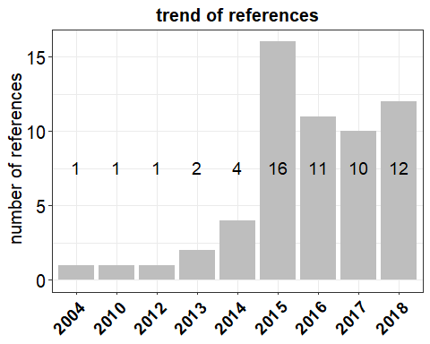

**Figure 1.** Number of references per year of publication.

Overall, we found *31* references reporting field tests with sensors co-located at urban sites, *8* references for rural sites and, *8* references for traffic sites. Most of the laboratory and field tests reported hourly averages with about *591* records obtained for over *85* models of OEMs and sensor systems. On the other hand, we found about *249* records from tests performed over an averaging time of 24 hours and 5 minutes with about *42* models of sensors (**Table S1**). Therefore, 1 hour averaged measurements were considered statistically more significant to represent most of the scrutinized *105* models of OEMs and sensor systems.

For the evaluation of sensors against reference systems we considered the metrics that were more frequently reported in the reviewed works about the evaluation of the sensor performance both in field and/or laboratory tests. The coefficient of determination is usually used as indication of “usefulness” or “goodness” of fit obtained from regression models comparing sensor measurements with reference measurements **Table S2**. However, is a partial measures of how sensors data agree with reference measurements according to a regression model5. A larger reflects an increase in the predictive precision of the regression model but it ignores the loss in information due to possible loss in degrees of freedom. A significance test is therefore suggested in this case. Alternatively, can be viewd as a measure of goddness of fit (how close evaluation data is to the reference measurements) and the slope of the regression as level of accuracy. However, if the goodness of fit about the regression is fixed, then the slope will increase and consequently also the . Therefore, when it happens to calibrate different datasets, calibration using slope and values close to 1.0 might be less precise than calibration using smaller values of slope and . As shown in **Table 2**, most of the works reported coefficients of determination as well as the of regression line mainly from field tests. Root mean square error () and the uncertainty (), were mostly computed as value of standard deviation and only reported in few works (*23*). Therefore, for the purpose of this work, we only focused on the analysis of the comparisons of and of laboratory and field tests of sensors.

Table 2. Number of records gathered by metric used in this work.

|  |  |  |
| --- | --- | --- |
| metrics | n. Field Tests | n. Laboratory Tests |
|  | 1155 | 135 |
| **from calibrations** | 213 | 64 |
| **from comparisons** | 1033 | 70 |
| **slope of reg. line** | 933 | 53 |
| **RMSE** | 162 | 5 |
| **Uncertainty (U)** | 45 | 29 |

# Classification of sensors

For each model of sensor system we identified the manufacturer of OEM sensor and the manufacturer of the sensor system itself including the sensors, protective box, internal hardware and software for data acquisition, data treatment and data transfer. Each database record describing the laboratory or field performance of a sensors was considered valuable only if it reported information about laboratory tests and/or field comparison against a reference measurement at a reference monitoring station. Overall, we found 105 models of sensors including both OEMs (38) and sensor systems (67) manufactured by 71 manufacturers (16 OEM and 55 SS). In addition, we identified 18 projects about the evaluation of OEMs/sensor systems under different operational conditions (Air Quality Egg, Air Quality Station, AirCasting,2,8,24,48, Carnegie Mellon24,75, CitiSense73 Cairsense31, Developer Kit2, HKEPD/14-0277164, making-sense.eu46, communitysensing.org68, MacPoll.eu58, OpenSense II7,47, Proof of Concept AirSensEUR27, SNAQ Heathrow45,53). Out of 1290 records collected from literature, we identified 1155 records (341 OEM and 814 SS) from 86 alive sensors (33 OEM and 53 SS) and 135 records (28 OEM and 107 SS ) from 19 “non active” (or discontinued) sensors (5 OEM and 14 SS).

Commonly speaking, “low-cost” refers to the cost of a sensor system compared to the cost of a reference instrument measuring the air pollutant39. More recently, ultra-affordable OEMs are starting to appear on the market for PM monitoring. Many of them are designed to be integrated in the Internet of things (IoT) network of devices. Currently, for the detection of PM_2.5, it is possible to purchase optical sensor at prices of few hundreds euros to few tens of euros from devices manufactured in emerging economies such as the Republic of China and Republic of Korea66. For the detection of PM_2.5, some of these sensors are starting achieving performances comparable to low-cost OEMs manufactured in the Western world.

## Raw data and traceability of data treatment

The data treatment of measurements of OEM sensors and sensor systems can be classified in two distinct categories:

1. Data acquisition and data processing of sensor data that are operated by an **“open source”** software tuned according to different calibration parameters and environmental conditions. All data treatments from data acquisition until the conversion to pollutant concentration levels is known to the user. Among *38* sensors, we identified *401* records from OEMs (*335* ) and sensor systems (*66*) using an open source software for data management. Usually, outputs from these sensor were already in the same measurement units as the reference measurements.In this category, sensor devices are generally connected to a custom-made data acquisition system to acquire sensor raw data. Generally, users are expected to set a calibration function in order to convert sensor raw data to validate against reference measurements. In this category, the sensor only consists of OEMs integrated in data acquisition system, in most cases with a posteriori data treatment.
2. Sensor systems with integrated built-in OEM sensors, data acquisition system and calibration algorithms whose data treatment is unknown and without the possibility to change any parameter have been identified as **“black box”**. This is because of the impossibility for the user to accurately know the whole chain of data treatment and to tuen the sensor itself. Among *72* sensors, we identified *889* records among OEMs (*34*) and sensor systems (*855*) not using an open source software for data management.In most cases, the sensor system wasare previously calibrated against a reference system or, the calibration parameters wereare remotely adjusted by the manufacturer.

Clear definitions and examples of the principle of operations used by the different type of sensor (electrochemical, metal oxides, optical particulate counter, optical sensors) are reported in a recent work by WMO39. This work also reports the several limitation of each type of sensor such as, interference by meteorological parameters, cross-sensitivities to other pollutants, drifts and aging effect. At the date, there is a larger number of active and commercially available sensors (**Figure 2**). However, while most of the OEM sensors are open sources, allowing end-users to integrate them into sensors systemes, most of the sensor systems themselves were found to be “black-box” devices. This represents a limitation when the sensor system might need further re-calibration other then the one provided by the manufacturer.

Sensor are also classified according to their commercial availability. Sensor were assigned to the “Commercial” category if they could be purchased and operated by any user without the need for another service for data treatment or reporting activing (as a consultant service for example). Sensors fell under category non-commercial when it was non possible to find any supplier for purchasing. Typically this type of sensor are used for research and publication while it is difficult for any user to repeat the same sensor setup.

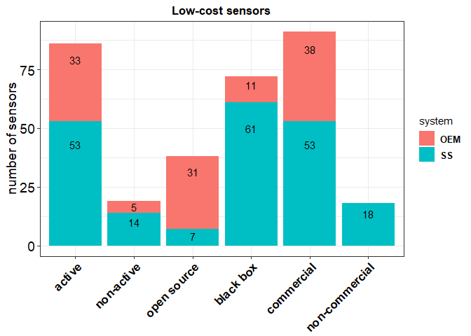

**Figure 2.** Number of sensor models gathered from the literature review. Sensors has ben classified by their type of technology, availability, openness and commerciality.

## Sensors for air quality

For the detection of Particulate Matter, the largest number of sensor tests, carried out with OEM and SS, was found for Optical Particle Counters (OPC) with *602* records followed by Nephelometers with *248* records (**Table 1**). Both systems detect particulate matter by measuring the light scattered by particles, with the OPC being able to directly count particles according to their size. On the other hand, nephelometers estimate particle density that is subsequently converted into particle mass. For the detection of gaseous pollutant such as, , and , the largest number of tests was found for electrochemical sensors with *306* records, followed by metal oxides sensors (MOs) with *112* records (**Table 2**). Electrochemical sensors are based on a chemical reactions between gases in the air and the working electrode of an electrochemical cells. The current of electrons being created is measured between the working and counter electrode that are dipped into an electrolyte in a metal oxide sensor (also named resistive sensor, semiconductor). Therefore, gases in the air react on the surface of a semi-conductor and exchange electrons modifying its conductance.

**Table S3** reports the models of OEM sensors currently used to monitor particulate matter according to principle of operation and the cut-off of particulate size. For the sake of clarity, we aggregated records from together with , and . The same was done for records that were aggregated with coarse . On the other hand, models of sensor systems measuring concentration of particulate matter were reported in **Table S4**1–4,8–10,12,18,20,22,24,25,27–34,37,38,43,48–50,52,54,63,69,70,72–75. Several sensor systems can use the same OEM. In very few cases, the same model of sensor system was tested using different types of OEM sensors when performing validation tests. **Table S5** and **Table S6** report the models of OEM and sensor systems, respectively, currently used to measure concentration of gaseous air pollutants , , and, according their their type of technology.2,6,7,9,11,12,19,21,23,24,26,28,31,37,44–47,51,56,58,59,61,62,64,65,67,68,71,73,76

# Calibration of Sensors

Calibration of the sensor is somewhat considered a sensitive information from most of sensor manufacturers. Several studies performed calibration of sensors during laboratory or field tests. The calibration consisted in the application of a regression model in order to adjust the response of the sensor to a reference system. We found calibration records for both OEMs and sensor systems. Overall, we gathered over *322* records about calibration of sensors using different types of mathematical models **(Table 3)** and at different time resolutions. The *linear* model and the multi linear regression model (*MLR*) were largely used to calibrate the sensor response against a reference measurement. Other calibration approaches used the *exponential*, *logarithmic*, *quadratic*, *Random Forest* and, few types of *neural network* models. We could observe that most of MLR models, covariates such as meteorological parameters *Temperature* and *Relative Humidity*, and gaseous pollutant such as, Nitric Dioxide (), Nitric Monoxide () and Ozone (), were used to optimize the calibration. Some types of model also took into cosnideration the of the sensor as covariate. The calibration of OEMs was performed using the raw signal of the sensor that most of the time was expressed as a voltage or as a current. On the other hand, for sensor systems, the calibration was carried out using the units of the reference system.

Table 3. Types of calibration models used for the calibration of sensors at different time resolutions (ANN: artificial neural network, exp: exponential; log: logarithmic; MLR: multilinear regression; quad: quadratic; RF: random forest; SVM: support vector machine; SVR: support vector regression)

|  |  |  |
| --- | --- | --- |
| calibration model | n. records | references |
| **ANN** | 8 | Cordero[19], Gerboles[27] |
| **exp** | 9 | Dacunto[22], AQ-SPEC[2], Kelly[34], Austin[3] |
| **linear** | 97 | Mukherjee[48], Sun[65], Spinelle[58], Wang[71], Alvarado[1], Cavaliere[12], Castell[11], Cross[21], Gerboles[26], Sousan[54], Northcross[49], Steinle[64], Han[29], Jovasevic[32], Olivares[50], Spinelle[59], Spinelle[60], Kelly[34], Zheng[75], Holstius[30], Zimmerman[77], Lin[41], AQ-SPEC[2] |
| **log** | 20 | AQ-SPEC[2], Laquai[38] |
| **MLR** | 125 | Jiao[31], Sun[65], Mijling[46], Spinelle[58], Mueller[47], Bigi[7], Cordero[19], Gerboles[27], Wei[72], Spinelle[57], Piedrahita[51], Spinelle[59], Spinelle[60], Sun[66], Zheng[75], Holstius[30], Zimmerman[77], Liu[42] |
| **quad** | 42 | Chakrabarti[18], AQ-SPEC[2], Manikonda[43], Alvarado[1], Zheng[75], Gao[25] |
| **RF** | 13 | Bigi[7], Cordero[19], Zimmerman[77], Liu[42] |
| **SVM** | 4 | Cordero[19] |
| **SVR** | 4 | Bigi[7] |

As explained above, from the analyzed records, we found several type of regression model that were used to calibrate sensors from OEM and sensor systems against reference systems. In order the estimate quality of the used calibration model, we reported the coefficient of determination as indication of the amount of total variability explained by the model. On a first instance, The coefficient of determination can be used as indication of performance of the calibration model chosen to validate the sensor with a reference system. In addition to simple linear models, raw sensor data were validated using multilinear and quadratic models which included the use of covariates to improve the quality of the calibration (**Table 3**).

**Figure 3** shows a summary of all mean obtained from the calibration of sensor systems against reference measurements. Results were grouped by model of sensor system and averaged per reference work. For the same sensor systems we can observe ranging from low to high values up to the unit. This show the variability of the performance of sensor systems depending from the type of calibration. In the following we are going to report a detailed discussion about performance of several OEM and sensor systmens during their calibration at different averaging-times.

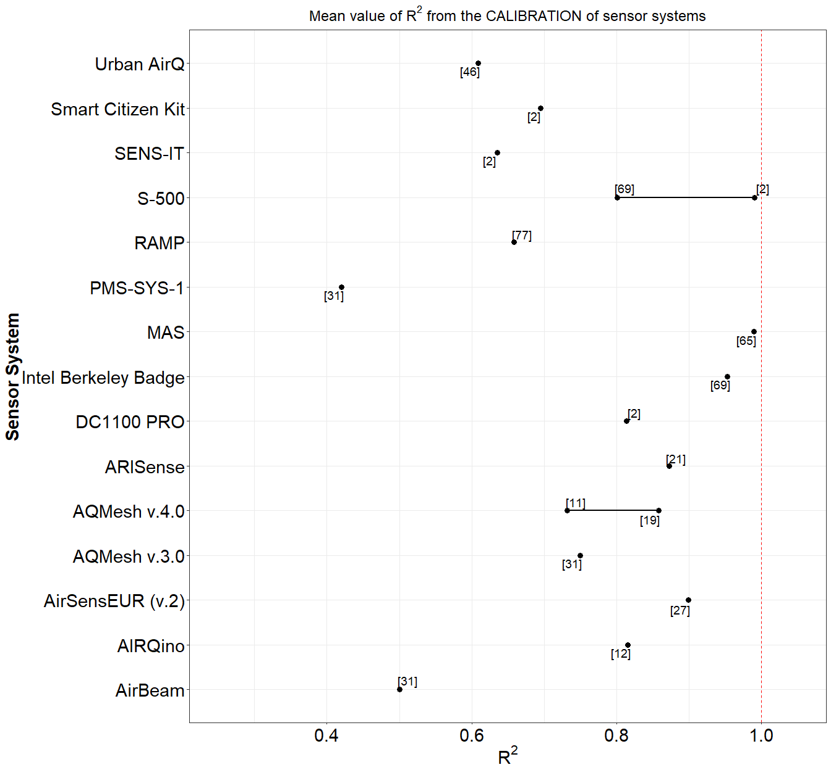

**Figure 3.** Mean for obtained from the calibration of sensor systems against reference measurements.

Calibration of sensor data against a reference system was found to be carried out using input data at different time resolution. Therefore, in order to make a comparison of obtained at the same time resolution data, we chose records averaged over different time-scale of 1 hour **(Figure S1)** and 1 minute **(Figure S2)**. Most of these records were from OEMs *(109)* whereas only a limited number were from sensor systems *(109)*. For the measurement of , values of ~ 1 were found for the sensors **PMS1003** by **Plantower**34 at 1-hour resolution and for the the **PMS3003** , **Dylos DC1100 PRO** and **DC1700** by **Dylos** at a resolution of 1 minute.2,63,74 The Plantower and Dylos sensors showed higher when calibrated with 1 minute resolution reference data. Other sensors such as, the **OPC-N2** by **AlphaSense**2 reported values of falling within the range of 0.7 - 1.0 at a resolution of 1 hour. The same OEM sensor OPC-N2, reported values of just above 0.7 when measuing while it did not show a good performance when measuring 2. We need to stress out that optical sensors, such as OPCs and nephelometers, are somewhat limited when detecting coarse particulate patter because of the low-efficiency of the sampling system when sampling large particles in ambient air.

Most of regression models used for the calibration of sensors detecting gaseous pollutants used a time-resolution of 1 hour. For the calibration of sensors measuring , the largest values of was reported for the OEM sensors **FIS SP-61** by **FIS** and **O3-3E1F** by **CityTechnology**, when using a time-resolution of 1 hour (**Figure S1**)56. On the other hand, when using a time-resolution of 1 minute, values of ~ 1 were found for the sensor system **AirSensEUR (v.2)** by **LiberaIntentio**27 as well as for the OEM **S-500** by **Aeroqual**2 (**Figure S2**). The AirSensEUR uses a built-in OEM **OX-A431**. We want to point out that, most of the MLR models used for calibration ozone sensors foresees the use of reference because of the strong oxidizing effect of on gas sensors with consequent formation of . For the calibration of sensors measuring we found values of within the range 0.7 - 1.0 for the OEM sensor **NO2-B42F** (by Alphasense71), at a time resolution of 1 hour, and the sensor systems **AirSensEUR (v.2)** (by LiberaIntentio)27) and **MAS**64 at a time resolution of 1 minute (Figure 3). We need to point out that for the measurement of , the AirSensEUR (v.2) uses the OEM sensor NO2-B43F by AlphaSense.

Most of the records about the calibration of sensor measuring showed high values of . As shown in Figure S1, the OEMs **CO 3E300** by **City Technology**26 and **CO-B4** by **Alphasense**71 reported ~ 1 for time-resolution of 1 hour. High values of were also reported for the sensor system **AirSensEUR (v.2)** when calibrating for at a time-resolution of 1 minute (Figure S2)27. Other sensors reporting values of within the range 0.7 - 1.0 where the **MICS-4515** by and **SGX Sensortech**51, the **Smart Citizen Kit** by **Acrobotic**2 and the **RAMP**76. All these sensors used 1 hour time-resolution data.

# Comparison with reference systems

We found about *1103* records about the comparison of calibrated sensors against a reference instrument. All comparisons were carried out by using a *linear regression* model between calibrated and reference data. The performance of the regression was evaluated with the coefficient of determination and the *slope* of the regression. As explained above, we need to stress out that not all the analyzed records reported the *Root Mean Square Error (RMSE)* of the regression therefore, we decided to omit it in the present review.

In this work, records gathered from the comparison of sensors with reference systems came from OEMs and sensor systems using a custom calibration or a built-in calibration directly setup by the manufacturer. As for the records collected from the calibration of sensor, comparison with reference system was carried out at different time-resolutions. Here we only report comparisons performed at a time-resolution of 1 hour with *416* and *169* records from sensor systems and OEMs, respectively. In **Figure 3a** we have reported the averaged for all reviewd sensor systems found from each reference workd. As for the evaluation of the calibration of sensors, we have averaged valuse obtained from the same raference and for the same sensor systems. It was observed that, for the same sensor system, we could find different value for the comparison with reference measurements. In the following we give a more detalied breakdown about the performances of each OEM / SS upon their comparison with reference mesurements at different averaging-times.

**Figure S3** shows the distribution of for sensors systems measuring , , , , and against reference at 1-hour time-resolution. For the measurements of particulate matter, most of the comparisons were performed during field tests with the highest obtained from the sensor **PA-II** by **PurpleAir**2 and **PATS+** by **Belkley Air**52. These sensors reported values of between 0.8 and 1.0. Other sensors with values falling in the range 0.7-1.0 were identified in the **PMS-SYS-1** by **Shinyei**, the **Dylos 1100 PRO** by **Dylos**, the **MicroPEM** by **RTI**, the **AirNUT** by **Moji China**  the **Egg (2018)** by **Air Quality Egg**, the **AQT410 v.1.15** by **Vaisala**, the **AirVeraCity** by **AirVeraCity** and, the **Air Quality Station** by **AS LUNG**2. Records from other sensors showed different values of depending of the type of field test and for the averaging time chosen to process the time-series of data. We need to point out that the performance of sensor systems measuring , on average, was very poor.

For gaseous pollutants, high values were found for the sensor systems **2B Tech. (POM)** by **2B Technologies** ()2, the **AirSensEUR (v.2)** by **LiberaIntentio**27 the **Bettair** by **Bettair Cities**6 the **AirCasting** by **HabitatMap**72 the **KUNAKAIR A10 V2** by **kunak**37 (, , and ), the **Spec**, the **AQMesh**. These sensors reported values of between 0.8 and 1.0. As shown in **Figure S3**, we found a non-negligible number of records for sensor systems whose resulting from the comparison with reference systems was within the range 0.7 - 1.0 using 1-hour averaged data. We want to point out that, among all tested sensor systems, only the **AirSensEUR (v.2)** was the only one measuring multiple pollutants.

The comparison of OEMs against reference systems, showed only few sensors for the measurement of had within the range 0.7 - 1.0 when average over a time-scale of 1 hour. Among them we could identify the **Dylos DC 1700**30,32,43,54 and the **OPC-N2** (**Figure S4**)2,4,20,24,48 when measuring . On the other hand, when the comparison was performed over a time-scale of 24 hour we found within the range 0.7 - 1.0 for several OEMs which included the **PMS7003** by **Plantower**4, the **SDS011** by **Nova Fitness**4, the **OPC-NO2**2, and the **Egg v.2 (PM)** by **Air Quality Egg**2 when measuring (**Figure S5**). The same behavior was observed from the comparison of sensor systems against a reference system when measuring 24-hour averaged data of . As we can see from **Figure S6**, several sensor systems such as, **Dylos DC 1700**49, **PA-II**,2 **AirQUINO** by **CNR**12 reported values of ~ 1.

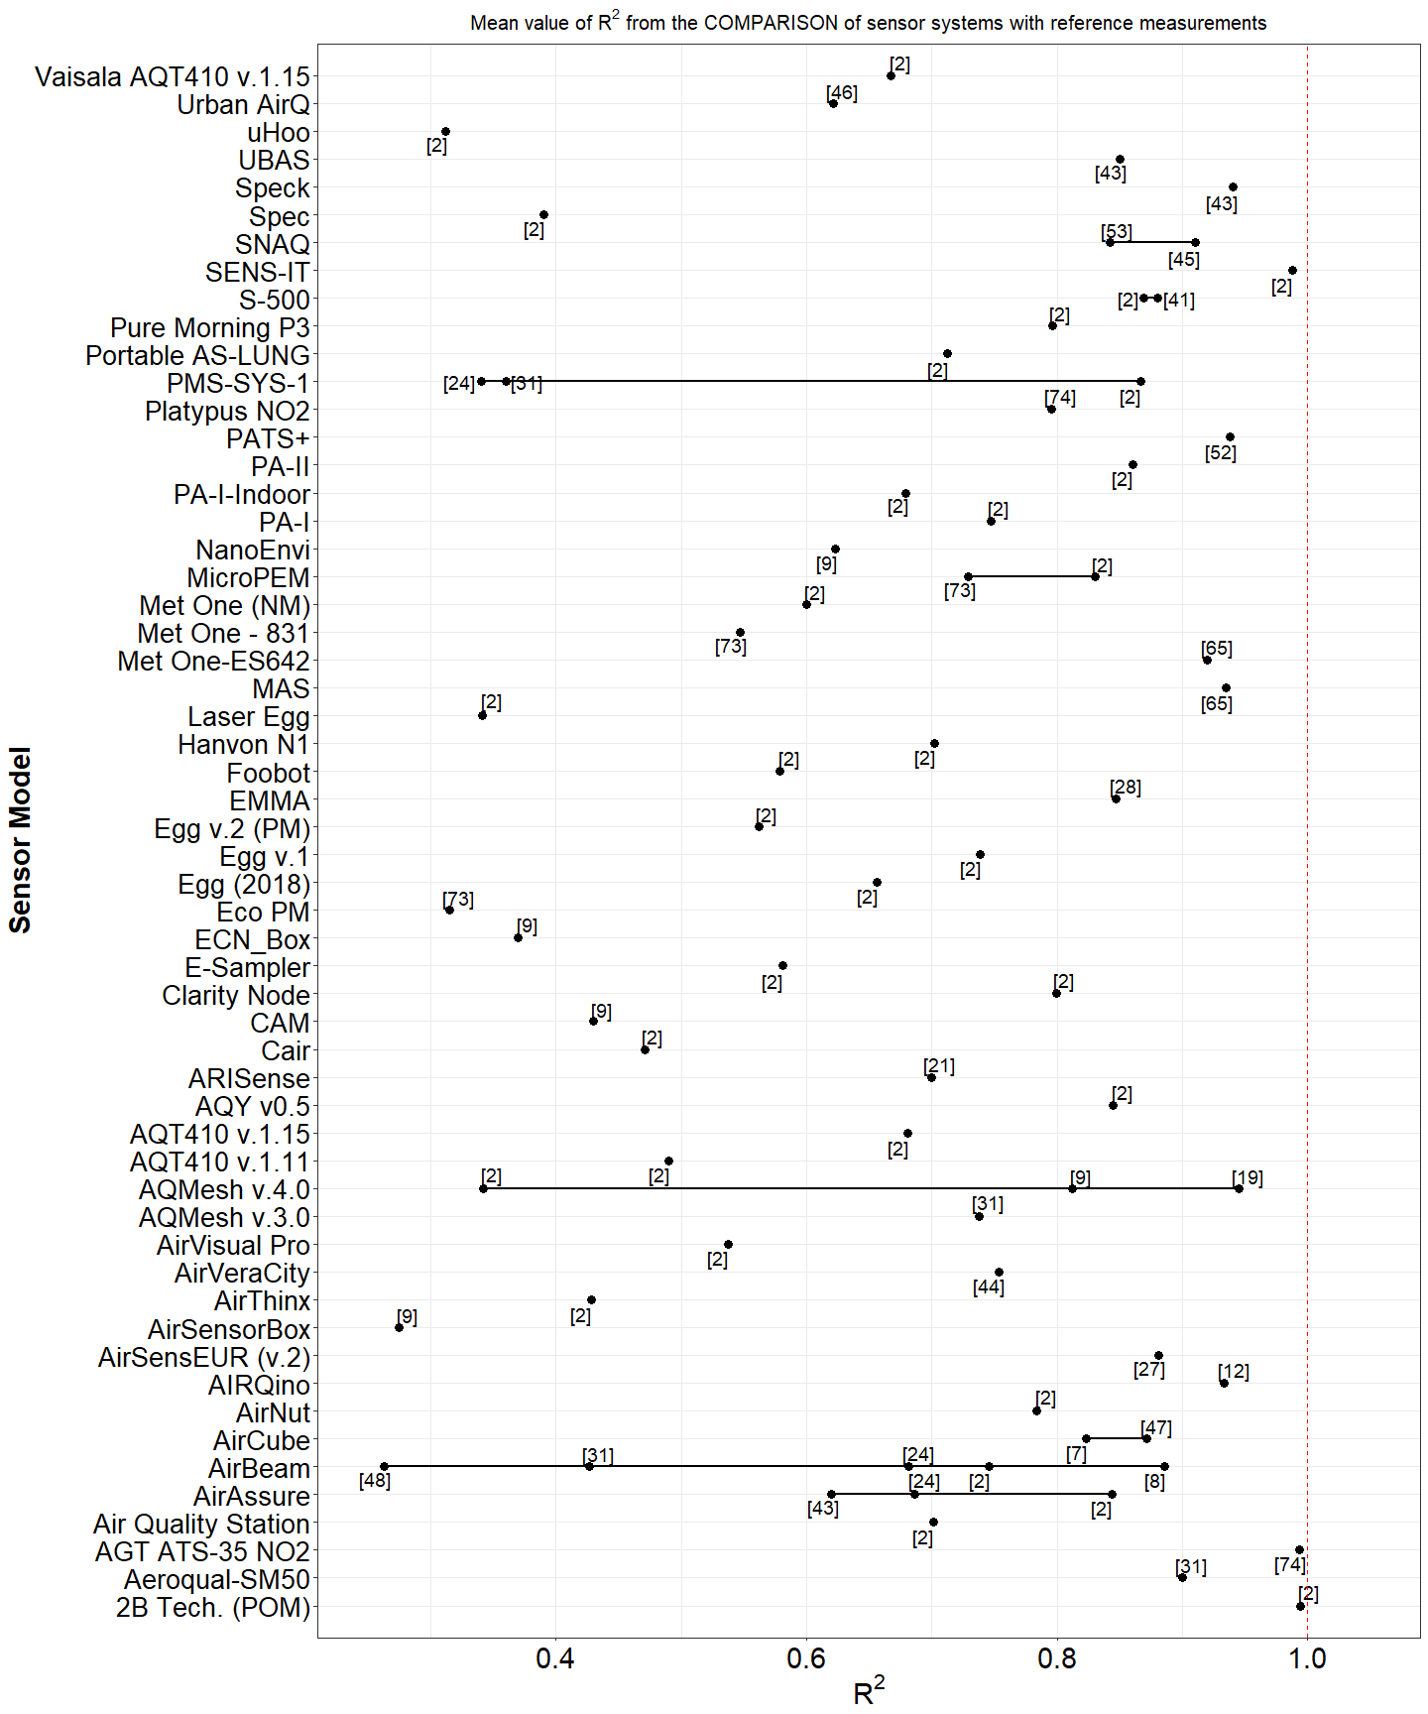

**Figure 3a.** Mean for obtained from the comparison of sensor systems against reference measurements.

For the evaluation of gaseous pollutants, we found very few OEMs with within 0.7 - 1.0 when using data at at time-resolution of 1 hour. These sensors included the **CairClip O3/NO2** by **CairPol**23,24,58,73, the **Aeroqual Series 500 (and SM50)**24, the **O3-3E1F** by **CityTechnology**24,26,58,60 and the **NO2-B43F** by **Alphasense**65,76 (**Figure S4**). On the other hand, we found very few records for sensor systems using 24 hour data. As a general remark, we can see that the performance of OEMs sensors is enhanced when they are integrated inside a sensor systems. It is also evident that most of the gathered records from and gaseous pollutants , , and , used 24 hours and 1 hour time-resolution data as required by the European Air Quality Directive.

To check the accuracy of a sensor, when compared to a reference system, we looked at the value of the slope obtained from the linear regression of the sensor measurements against a reference measurement. Most of comparisons were carried out during field tests, while only a limited number laboratory tests were available. Ideally, only an ~ 1.0 and a **slope** ~ 1.0 should be a good indicator of performance for a sensor. Therefore, we only selected records with > 0.7 and **slope** within the range 0.5-1.5.

**Figure S7** shows sensor systems such as, the **AQM 60**, the **KUNAKAIR A10 V2**, the **AirSensEUR (v2)** has ~ 1 for most of measured gaseous pollutants when using 1 hour time-resolution data. On the other hand, only few records from sensor systems showed ~ 1 for 1-hour (**PATS+** and **AirNut**) and 24-hour (**AIRQuino**) time-averaged sensor systems. Only few sensors performed well at ideal conditions. Sensor systems such as, **AIRQino**, **SidePak AM510**, **Air Quality Egg (v.2) (PM)**, **Dylos DC1100 PRO**, **AirNut** and the OEM **OPC-N2** were in good agreement with a reference system (**Figure S7**, **Figure S8**).

Among OMEs showing ~ 1 when using 1-hour time-averaged data, we found the **SM50**, the **CairClip O3/NO2**, the **S-500**, (, ) and, the **NO2-B4F** () and the **Egg v.2 (PM)** () (**Figure S9**). On the other hand, when using 24-hour time-averaged data, the OEM **OPC-N2** by **Alphasense** and the **Egg v.2 (PM)** by **Air Quality Egg**, shoed slopes ~ 1 when measuring (**Figure S10**).

As general remark, from the above analysis we could observe that for some OEMs and sensor systems, the width of the interquartile range IQR (H-spread) was very narrow. This is an indication of the *reproducibility* of the regression parameters used in their calibration. This becomes relevant when it comes to the development of a reliable sensor system that uses the same OEM sensor and the same calibration algorithms. From the present analysis,

# Price of sensors

As preliminary outcome of the present analysis, we have started identifying sensors systems that are in good agreement with reference instruments commonly used to monitor pollutant concentrations. Although the sensor market constantly develops, we decided to identify a sensor system that is commercially available or that can be assembled with commercially available OEM sensors.

Usually, the price of OEM sensors only represents a small fraction of the selling value of the entire sensor system. In the common understanding, a sensor for air quality is classified as low-cost when its price is less than 10000 EUR. In addition, if a low-cost sensor can measure multiple pollutants, potentially it could be used by local authorities as complementary source of air quality data as subsitute of reference instruments whose cost might rise up to one order of magnitude.

For the evaluation of the price of sensors, we considered all sensor systems manufactured by commercial companies as well as sensor systems built for laboratory testing by research groups. The latter ones are custom-built devices assembled around an OEM sensor. We must to stress out that, while for the detection of different size of particulate matter it is possible to use the same optical sensor, for the detection of gaseous pollutant it is necessary to have a dedicated sensor for each pollutant. Therefore, among all the analyzed records, we tried identifying sensor systems that can measure concentration of particulate matter together with gaseous pollutants.

**Figure S12** and **Figure 4** show the commercial price of OEMs and sensor systems by model and number of pollutant measured by each sensor. There is a large number of sensor systems measuring single pollutants but few ones measuring multiple pollutants. This is an indication about the complexity to have a sensor system measuring multiple pollutants. Most of OEMs are open source devices (**Figure S12**). This means that OEMs can be used to build sensor systems for data acquisition and therefore to calibrate the sensor. On the other hand, most of the sensor systems are black box (**Figure 4**). This means that most of the manufacturers of sensor systems does not commercialize sensors that can be re-calibrated according to the requirements of the user. Sensor systems are intended to be ready-to-use air quality monitors. When purchased by the end-user, a sensor system should estimate the concentration of pollutants with a close agreement to the traditional reference systems used to monitor air quality.

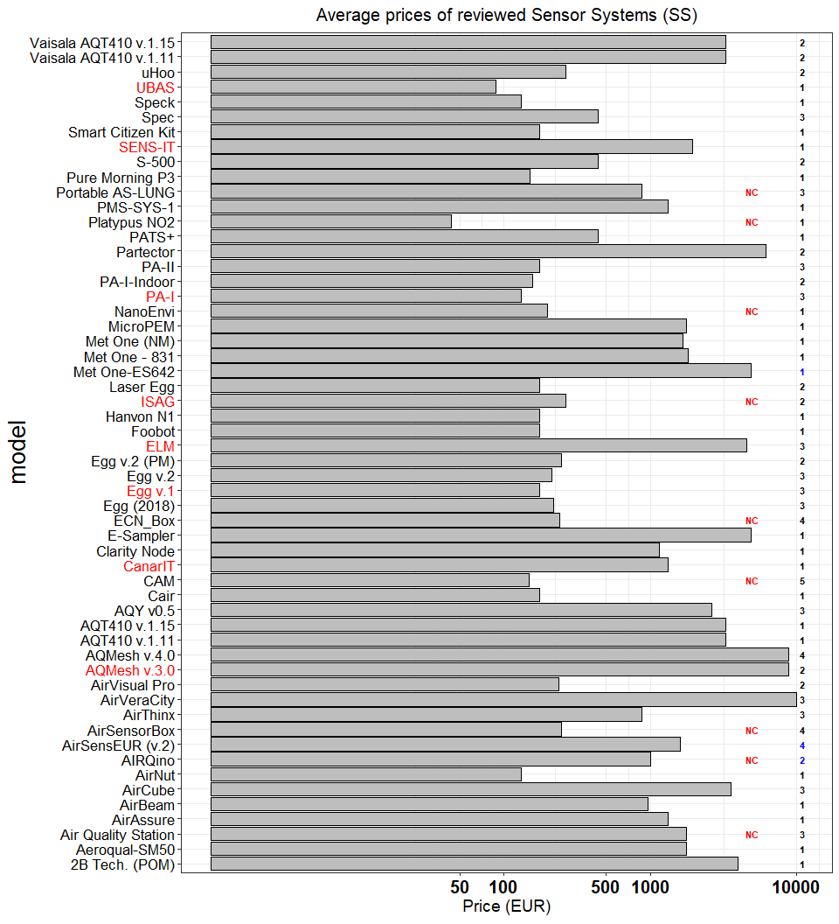

**Figure 4.** Prices of SS grouped by model. (Numbers in bold indicates the number of pollutant measured by each sensor. x-axis uses logarithmic scale). Numbers in bold indicate the number of open source (blue) and black box (black) records. Names of ‘living’ & ‘updated’ and ‘non-living’ sensors are indicated in black and red color, respectively. indicates non commercially available sensor.

In **Figure 5** We have shortlisted sensor systems according to their level of agreement to reference systems. For this purpose, we considered metrics obtained from 1 hour and 24 hour averaged data of sensor systems with > 0.85 and 0.8 < < 1.2.

Among open source sensor systems we could identify the **AirSensEUR (v.2)** by **LiberaIntentio** and the **AIRQuino** by the **CNR** for the detection of , , , and , respectively. The remaining shortlisted sensor systems were identified as black box. **Table 4** and **Table S7** report the mean value of and of the for the sensors systems shortlisted in Figure 15 for 1 hour and 24 hour averaged data. As we can see, the **AirSensEUR (v.2)** resulted in a mean value of ~ 0.90 and a of ~ 0.94 while the **AIRQuino** resulted in a mean value of ~ 0.91 and a of ~ 0.97. We need to point out that, at the date, the **AIRQuino** can measures up to five pollutants (, , , , and , and ), however, only data fror were available a the time of this review. On the other hand, the **AirSensEUR (v2)** is a complete sensor system that can also measure particulate matter beside gaseous pollutants including “ and (radon)”. This sensor system is already operative and has undergone multiple calibrations and field tests where measurements of gaseous pollutants showing good agreement with reference measurements.

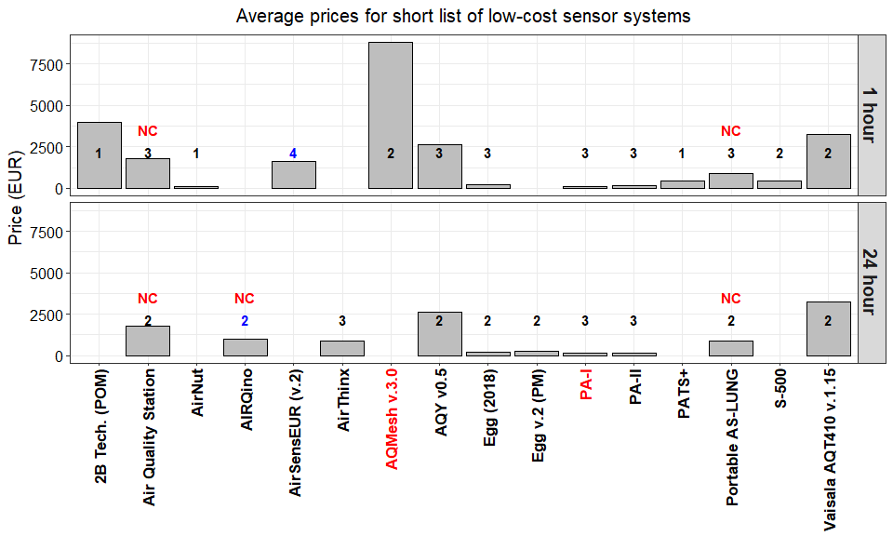

**Figure 5.** Price of low-cost sensor systems. Numbers in bold indicate the number of pollutant measured by open source (blue) and black box (black) sensors. Only records with > 0.85 and 0.8 < < 1.2 are shown. Names of ‘living’ & ‘updated’ and ‘non-living’ sensors are indicated in black and red color, respectively. indicates non commercially available sensor.

As shown in **Table 4**, the price of sensor systems ranged from few hundreds of euros to about 9000 euros. We have investigated the possibility of having a relationship between the performance of the sensor (here expressed as ) and the selling price of the sensor. For this purpose we have compared the mean of all sensor models against their price.

Table 4. Shortlist of sensor systems showing good agreement with reference systems ( > 0.85; 0.8 < slope < 1.2) for 1 hour time averaged data.

|  |  |  |  |  |  |  |  |
| --- | --- | --- | --- | --- | --- | --- | --- |
| model | pollutant | mean | mean slope | open/close | living | commercial | price (EUR) |
| **AirNut** |  | 0.8618 | 0.8838 | black box | Y | commercial | 132 |
| **PA-I** |  | 0.9464 | 0.9234 | black box | N | commercial | 132 |
| **PA-II** |  | 0.9874 | 0.823 | black box | Y | commercial | 176 |
| **Egg (2018)** |  | 0.8736 | 0.8484 | black box | Y | commercial | 219 |
| **PATS+** |  | 0.96 | 0.92 | black box | Y | commercial | 440 |
| **S-500** | , | 0.88 | 1.03 | black box | Y | commercial | 440 |
| **Portable AS-LUNG** |  | 0.8858 | 0.8678 | black box | Y | non commercial | 880 |
| **AirSensEUR (v.2)** | , , , | 0.8938 | 0.9425 | open source | Y | commercial | 1600 |
| **Air Quality Station** |  | 0.88 | 0.896 | black box | Y | non commercial | 1760 |
| **AQY v0.5** |  | 0.8654 | 0.9673 | black box | updated | commercial | 2640 |
| **Vaisala AQT410 v.1.15** |  | 0.8734 | 0.97 | black box | Y | commercial | 3256 |
| **2B Tech. (POM)** |  | 0.9972 | 1.007 | black box | Y | commercial | 3960 |
| **AQMesh v.3.0** |  | 0.87 | 0.883 | black box | N | commercial | 8800 |

In **Figure 6** we reported the relation between the mean and the selling price of OEM/SS for field tests comparisons of sensors against reference systems using 1 hour averaged data. As shown in **Figure 6**, we did not find a significative relation between the commercial price of OEM sensors and the value of . On the other hand, we could observe a slight increase of the price of sensor systems together with . The regression equations indicated in **Figure 6** have been calculated only considering “living” (or active) OEM/sensor when compared to reference measurements during field tests. For 24 hour averaged data from both OEMs and SS we did not show any relationship between mean and selling price.

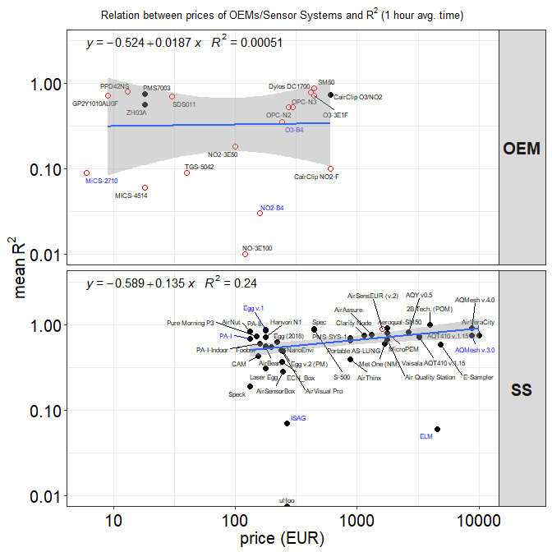

**Figure 6.** Relation between prices of OEMs/Sensor Systems (SS) and for field test only. Logarithmic scale has been set for both axis. Open source and black box models are indicated with open and full circles, respectively. Names of ‘living’ and ‘non-living’ sensors are indicated in black and blue color, respectively. refers to data averaged over 1 hour. Grey shade in the fit plots indicate a pointwise 95% confidence interval on the fitted values.

As shown in **Figure 6**, most of the reviewed sensor systems are “black box” systems. This means that the end-user cannot perform any further correction or re-calibration on the sensor system itself. The relationship observed between the coefficient of determination and the price of the sensor system, it is an evidence that complexity of building a detector for air quality is somewhat linked to the choice of materials, multi-functionality and time-spent to develop a reliable sensor system.

In order to target sensor systems in closer agreement and accuracy with reference systems, we displayed the distribution of SS models with > 0.75 and 0.5 < < 1.2. **Figure 7** indicates the **2B Tech. (POM)** by **2B Technologies**, the **AirSensEUR (v.2)** by **Liberantentio**, the **S-500** by **Aeroqual**, the **Egg (v.2)** by **Air Quality Egg**, the **AQT410 v.1.15** by **Vaisala** and the **AirVeraCity** as the one having –> 1 and $ = 1. These sensor systems give indicative measurements of air pollutants when comparared with the traditional reference monitoring systems over 1 hour averaging time. On the other hand, other sensors such as the **PA-II** by **Purple Air**, the **AirNut**, the **AQMesh v.3.0** by **AQMesh** and, the **AQY v0.5** by **Aeroqual** showed good agreement with reference systems but lower accuracy.

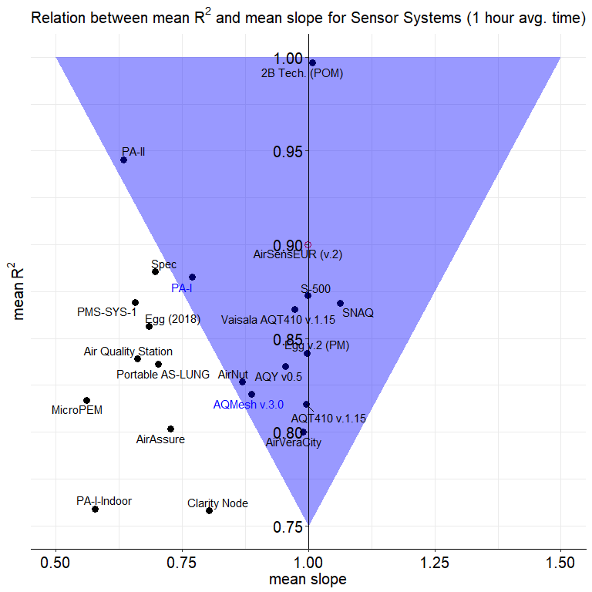

**Figure 7.** Correspondence between and slope for sensor systems (SS). Only sensor models with > 0.75 and 0.5 < < 1.2 are shown. Names of ‘living’ and ‘non-living’ sensors are indicated in black and blue color, respectively.

# Conclusions

According to the European Air Quality Directive2, a sensor system can be considered “Equivalent” when it meets the Data Quality Objectives (DQOs) set for data capture and uncertainty3,4 .In order for sensor system measurement to be incorporated into the legal framework set by the Air Quality Directive in Europe, they shall satisfy one of the data quality objectives (DQOs) of the Directive. DQOs, defined as the maximum allowed relative uncertainty, are defined either for reference and indicative measurements or for objective estimations. For inorganic gaseous pollutants, they correspond to 15, 25 to 30 and 75 %, respectively. Although, the objective of sensor systems is to provide the most accurate air pollution measurements, it is most likely that the DQO for reference measurements is out reach while it is believed that by improving the sensor calibration procedures the DQO of “Indicative Measurements” could be met at fixed monitoring sites35.

In conclusion to this market analysis, the only sensor system satisfying the requirements of multipollutant, availability of raw data, transparency of all applied data treatment, availability of evaluation of the performance of sensor system in literature with high coefficient of determination (>0.85) has been found to be the AirSensEUR v.2.

Supplementary material

Table S1. Number of analyzed records and sensor models by averaging time.

|  |  |  |
| --- | --- | --- |
| Averaging time | n. records | n. OEMs & SS |
| **1 hour** | 591 | 85 |
| **5 min** | 253 | 42 |
| **24 hour** | 249 | 42 |
| **1 min** | 102 | 23 |

Table S2. Metrics used for comparing sensor data, , and reference measurements, .

|  |  |  |  |
| --- | --- | --- | --- |
| Comparison metrics | Short name | Mathematical formulas | Characteristics |
| **Coefficient of determination** |  | , where SS_RES is the sum of squares of residuals and SS_TOT is the total sum of squares | measures the strentgth of relationship between and , of the percentage of total variance that is explained by a linear relationship |
| **Slope of linear relation ship** |  |  |  |
| **Intercept of the linear relationship Mi = Slope RMI + Offset** |  |  |  |
| **Root Mean Square Error** |  |  | indicates the magnitude of the error and retains the variable’s unit; is sensitive to extreme values and to outliers; tends to vary as a function of the standard deviation of the RM |
| **Measurement uncertainty** |  |  |  |
| **Correlation Coefficient** |  |  | measures the strength and the direction of a linear relationship between two variables, and receives a value between -1 and 1; is independent of the difference in the variance (var) of M and RM, thus if r=1 and var(M)<var(RM), then variance correction may be required |

Table S3. Model of OEMs for the detection of Particulate Matter.

|  |  |  |  |  |  |  |
| --- | --- | --- | --- | --- | --- | --- |
|  | model | type | pollutant |  |  | references |
| 1 | **CairClip PM2.5** | nephelometer |  |  |  | Williams[73] |
| 2 | **DataRAM pDR-1200** | nephelometer |  |  |  | Chakrabarti[18] |
| 3 | **DN7C3CA006** | nephelometer |  |  |  | Sousan[54] |
| 4 | **DSM501A** | nephelometer |  |  |  | Wang[71], Alvarado[1] |
| 5 | **Dylos DC1100** | OPC |  |  |  | Jiao[31], Williams[73], Feinberg[24] |
| 6 | **Dylos DC1100 PRO** | OPC |  |  |  | Jiao[31], AQ-SPEC[2], Manikonda[43] |
| 19 | **Dylos DC1100 PRO** | OPC |  |  |  | Feinberg[24], Manikonda[43] |
| 7 | **Dylos DC1700** | OPC |  |  |  | Manikonda[43], Northcross[49], Holstius[30], Steinle[64], Han[29], Jovasevic[32], Dacunto[22] |
| 20 | **Dylos DC1700** | OPC |  |  |  | Manikonda[43], Sousan[54], Han[29], Jovasevic[32] |
| 8 | **GP2Y1010AU0F** | nephelometer |  |  |  | Olivares[50], Manikonda[43], Sousan[54], Alvarado[1], Wang[71] |
| 21 | **GP2Y1010AU0F** | nephelometer |  |  |  | Alvarado[1] |
| 9 | **OPC-N2** | OPC |  |  |  | AQ-SPEC[2], Mukherjee[48], Sousan[55], Feinberg[24], Crilley[20], Badura[4] |
| 22 | **OPC-N2** | OPC |  |  |  | AQ-SPEC[2], Sousan[55], Feinberg[24], Crilley[20] |
| 24 | **OPC-N2** | OPC |  |  |  | AQ-SPEC[2], Sousan[55], Crilley[20] |
| 10 | **OPC-N3** | OPC |  |  |  | AQ-SPEC[2] |
| 11 | **PMS1003** | OPC |  |  |  | Kelly[34] |
| 12 | **PMS3003** | OPC |  |  |  | Zheng[75], Kelly[34] |
| 13 | **PMS5003** | OPC |  |  |  | Laquai[38] |
| 14 | **PMS7003** | OPC |  |  |  | Badura[4] |
| 15 | **PPD42NS** | nephelometer |  |  |  | Wang[71], Holstius[30], Austin[3], Gao[25], Kelly[34] |
| 16 | **SDS011** | OPC |  |  |  | Budde[10], Laquai[38], Badura[4], Liu[42] |
| 23 | **SDS011** | OPC |  |  |  | Budde[10] |
| 17 | **SidePak AM510** | nephelometer |  |  |  | Karagulian[33] |
| 18 | **ZH03A** | nephelometer |  |  |  | Badura[4] |

Table S4. Models of Sensor Systems for the detection of Particulate Matter.

|  |  |  |  |  |  |  |
| --- | --- | --- | --- | --- | --- | --- |
|  | model | type | pollutant |  |  | references |
| 1 | **Air Quality Station** | OPC |  |  |  | AQ-SPEC[2] |
| 2 | **AirAssure** | nephelometer |  |  |  | AQ-SPEC[2], Feinberg[24], Manikonda[43] |
| 3 | **AirBeam** | nephelometer |  |  |  | Borghi[8], Jiao[31] |
| 4 | **AirBeam** | OPC |  |  |  | AQ-SPEC[2], Mukherjee[48], Feinberg[24] |
| 5 | **AirNut** | nephelometer |  |  |  | AQ-SPEC[2] |
| 6 | **AIRQino** | OPC |  |  |  | Cavaliere[12] |
| 36 | **AirSensorBox** | OPC |  |  |  | Borrego[9] |
| 7 | **AirThinx** | OPC |  |  |  | AQ-SPEC[2] |
| 8 | **AirVisual Pro** | nephelometer |  |  |  | AQ-SPEC[2] |
| 9 | **AQY v0.5** | OPC |  |  |  | AQ-SPEC[2] |
| 10 | **Cair** | OPC |  |  |  | AQ-SPEC[2] |
| 11 | **CAM** | OPC |  |  |  | Borrego[9] |
| 37 | **CAM** | nephelometer |  |  |  | Borrego[9] |
| 12 | **Clarity Node** | nephelometer |  |  |  | AQ-SPEC[2] |
| 13 | **DC1100 PRO** | OPC |  |  |  | AQ-SPEC[2] |
| 14 | **E-Sampler** | OPC |  |  |  | AQ-SPEC[2] |
| 15 | **ECN_Box** | nephelometer |  |  |  | Borrego[9] |
| 40 | **Eco PM** | OPC |  |  |  | Williams[73] |
| 16 | **Egg (2018)** | OPC |  |  |  | AQ-SPEC[2] |
| 17 | **Egg v.2 (PM)** | nephelometer |  |  |  | AQ-SPEC[2] |
| 38 | **ELM** | nephelometer |  |  |  | AQ-SPEC[2] |
| 18 | **EMMA** | OPC |  |  |  | Gillooly[28] |
| 19 | **Foobot** | OPC |  |  |  | AQ-SPEC[2] |
| 20 | **Hanvon N1** | nephelometer |  |  |  | AQ-SPEC[2] |
| 21 | **Laser Egg** | nephelometer |  |  |  | AQ-SPEC[2] |
| 22 | **Met One-ES642** | nephelometer |  |  |  | Sun[65] |
| 39 | **Met One - 831** | OPC |  |  |  | Williams[73] |
| 23 | **Met One (NM)** | OPC |  |  |  | AQ-SPEC[2] |
| 24 | **MicroPEM** | nephelometer |  |  |  | AQ-SPEC[2], Williams[73] |
| 25 | **PA-I** | OPC |  |  |  | AQ-SPEC[2] |
| 26 | **PA-I-Indoor** | OPC |  |  |  | AQ-SPEC[2] |
| 27 | **PA-II** | OPC |  |  |  | AQ-SPEC[2] |
| 28 | **Partector** | Electrical |  |  |  | AQ-SPEC[2] |
| 29 | **PATS+** | nephelometer |  |  |  | Pillarisetti[52] |
| 30 | **PMS-SYS-1** | nephelometer |  |  |  | Jiao[31], AQ-SPEC[2], Williams[73], Feinberg[24] |
| 31 | **Portable AS-LUNG** | OPC |  |  |  | AQ-SPEC[2] |
| 32 | **Pure Morning P3** | OPC |  |  |  | AQ-SPEC[2] |
| 33 | **Speck** | nephelometer |  |  |  | Feinberg[24], US-EPA[68], Williams[73], AQ-SPEC[2], Manikonda[43], Zikova[76] |
| 34 | **UBAS** | nephelometer |  |  |  | Manikonda[43] |
| 35 | **uHoo** | nephelometer |  |  |  | AQ-SPEC[2] |

Table S5. Model of OEMs for the detection of , , and .

|  |  |  |  |  |  |  |  |
| --- | --- | --- | --- | --- | --- | --- | --- |
|  | model | type | pollutant |  |  |  | references |
| 1 | **CairClip NO2-F** | electrochemical |  |  |  |  | Spinelle[56], Spinelle[58], Duvall[23] |
| 2 | **CairClip O3/NO2** | electrochemical |  |  |  |  | Jiao[31], Williams[74] |
| 16 | **CairClip O3/NO2** | electrochemical |  |  |  |  | Jiao[31], Spinelle[56], Duvall[23], Feinberg[24] |
| 10 | **CO-B4** | electrochemical |  |  |  |  | Wei[72] |
| 11 | **CO 3E300** | electrochemical |  |  |  |  | Gerboles[26] |
| 17 | **FIS SP-61** | MOs |  |  |  |  | Spinelle[57] |
| 3 | **MiCS-2710** | MOs |  |  |  |  | Spinelle[58], Williams[74] |
| 4 | **MICS-4514** | MOs |  |  |  |  | Spinelle[58] |
| 12 | **MICS-4514** | MOs |  |  |  |  | Spinelle[59] |
| 14 | **NO-3E100** | electrochemical |  |  |  |  | Spinelle[60], Gerboles[26] |
| 15 | **NO-B4** | electrochemical |  |  |  |  | Wei[72] |
| 5 | **NO2-3E50** | electrochemical |  |  |  |  | Spinelle[58], Spinelle[56], Gerboles[26] |
| 6 | **NO2-A1** | electrochemical |  |  |  |  | Williams[74] |
| 7 | **NO2-B4** | electrochemical |  |  |  |  | Spinelle[56], Spinelle[58] |
| 8 | **NO2-B42F** | electrochemical |  |  |  |  | Wei[72] |
| 9 | **NO2-B43F** | electrochemical |  |  |  |  | Sun[66] |
| 18 | **O3-3E1F** | electrochemical |  |  |  |  | Spinelle[56], Spinelle[58], Gerboles[26] |
| 19 | **O3-B4** | electrochemical |  |  |  |  | Spinelle[56], Spinelle[58], Wei[72] |
| 20 | **SM50** | MOs |  |  |  |  | Feinberg[24] |
| 13 | **TGS-5042** | electrochemical |  |  |  |  | Spinelle[59] |

Table S6. Model of Sensor Systems for the detection of , , and .

|  |  |  |  |  |  |  |  |
| --- | --- | --- | --- | --- | --- | --- | --- |
|  | model | type | pollutant | pollutant.y |  |  | references |
| 35 | **2B Tech. (POM)** | UV |  |  |  |  | AQ-SPEC[2] |
| 36 | **Aeroqual-SM50** | MOs |  |  |  |  | Jiao[31] |
| 1 | **AGT ATS-35 NO2** | MOs |  |  |  |  | Williams[74] |
| 2 | **AirCube** | electrochemical |  |  |  |  | Mueller[47], Bigi[7] |
| 34 | **AirCube** | electrochemical |  |  |  |  | Bigi[7] |
| 37 | **AirCube** | electrochemical |  |  |  |  | Mueller[47] |
| 3 | **AirSensEUR (v.2)** | electrochemical |  |  |  |  | Gerboles[27] |
| 4 | **AirSensorBox** | electrochemical |  |  |  |  | Borrego[9] |
| 5 | **AirVeraCity** | electrochemical |  |  |  |  | Marjovi[44] |
| 31 | **AQMesh v.3.0** | electrochemical |  |  |  |  | Jiao[31] |
| 6 | **AQMesh v.4.0** | electrochemical |  |  |  |  | Cordero[19], AQ-SPEC[2], Castell[11], Borrego[9] |
| 32 | **AQMesh v.4.0** | electrochemical |  |  |  |  | AQ-SPEC[2], Castell[11], Borrego[9] |
| 38 | **AQMesh v.4.0** | electrochemical |  |  |  |  | Castell[11], Borrego[9] |
| 39 | **AQT410 v.1.11** | electrochemical |  |  |  |  | AQ-SPEC[2] |
| 40 | **AQT410 v.1.15** | electrochemical |  |  |  |  | AQ-SPEC[2] |
| 7 | **AQY v0.5** | electrochemical |  |  |  |  | AQ-SPEC[2] |
| 41 | **AQY v0.5** | MOs |  |  |  |  | AQ-SPEC[2] |
| 8 | **ARISense** | electrochemical |  |  |  |  | Cross[21] |
| 9 | **CAM** | electrochemical |  |  |  |  | Borrego[9] |
| 10 | **ECN_Box** | electrochemical |  |  |  |  | Borrego[9] |
| 11 | **Egg v.1** | MOs |  |  |  |  | AQ-SPEC[2] |
| 12 | **Egg v.2** | electrochemical |  |  |  |  | AQ-SPEC[2] |
| 13 | **ELM** | MOs |  |  |  |  | AQ-SPEC[2], US-EPA[68] |
| 42 | **ELM** | MOs |  |  |  |  | AQ-SPEC[2] |
| 14 | **EMMA** | electrochemical |  |  |  |  | Gillooly[28] |
| 15 | **Intel Berkeley Badge** | electrochemical |  |  |  |  | Vaughn[69] |
| 16 | **Intel Berkeley Badge** | MOs |  |  |  |  | Vaughn[69] |
| 17 | **ISAG** | MOs |  |  |  |  | Borrego[9] |
| 18 | **M-POD** | MOs |  |  |  |  | Piedrahita[51] |
| 19 | **MAS** | electrochemical |  |  |  |  | Sun[65] |
| 43 | **MAS** | UV |  |  |  |  | Sun[65] |
| 20 | **NanoEnvi** | electrochemical |  |  |  |  | Borrego[9] |
| 44 | **NanoEnvi** | MOs |  |  |  |  | Borrego[9] |
| 21 | **Platypus NO2** | MOs |  |  |  |  | Williams[74] |
| 22 | **RAMP** | electrochemical |  |  |  |  | Zimmerman[77] |
| 23 | **S-500** | electrochemical |  |  |  |  | Lin[41] |
| 24 | **S-500** | MOs |  |  |  |  | Vaughn[69] |
| 45 | **S-500** | MOs |  |  |  |  | AQ-SPEC[2] |
| 25 | **SENS-IT** | MOs |  |  |  |  | AQ-SPEC[2] |
| 33 | **Smart Citizen Kit** | MOs |  |  |  |  | AQ-SPEC[2] |
| 26 | **SNAQ** | electrochemical |  |  |  |  | Mead[45], Popoola[53] |
| 27 | **Spec** | electrochemical |  |  |  |  | AQ-SPEC[2] |
| 46 | **uHoo** | MOs |  |  |  |  | AQ-SPEC[2] |
| 28 | **Urban AirQ** | electrochemical |  |  |  |  | Mijling[46] |
| 29 | **Vaisala AQT410 v.1.11** | electrochemical |  |  |  |  | AQ-SPEC[2] |
| 30 | **Vaisala AQT410 v.1.15** | electrochemical |  |  |  |  | AQ-SPEC[2] |

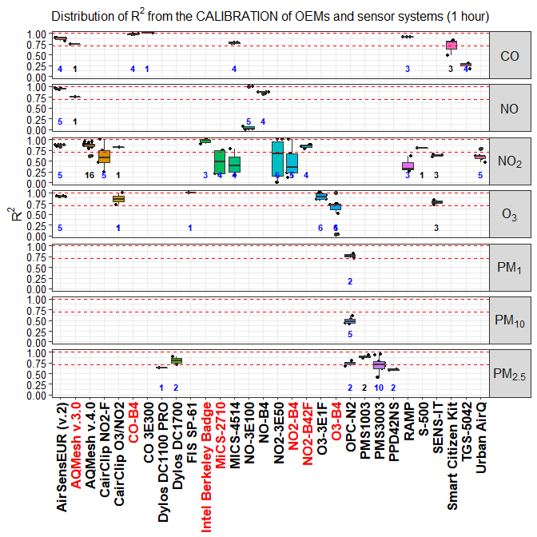

**Figure S1.** Distribution of for OEMs and sensor systems against the reference for different pollutants. Records were averaged over a time-scale of 1 hour. Dashed lines indicate the value of 0.7 and 1.0. Numbers in bold indicate the number of open source (blue) and black box (black) records. Names of ‘living’ and ‘non-living’ sensors are indicated in black and red color, respectively.

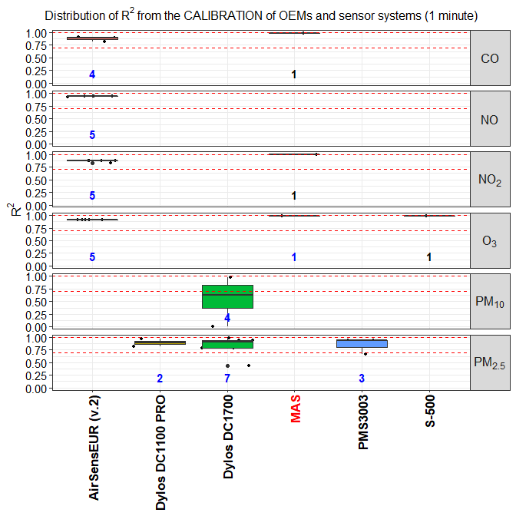

**Figure S2.** Distribution of for OEMs and sensor systems against the reference for different pollutants. Records were averaged over a time-scale of 1 minute. Dashed lines indicate the value of 0.7 and 1.0. Numbers in bold indicate the number of open source (blue) and black box (black) records. Names of ‘living’ and ‘non-living’ sensors are indicated in black and red color, respectively.

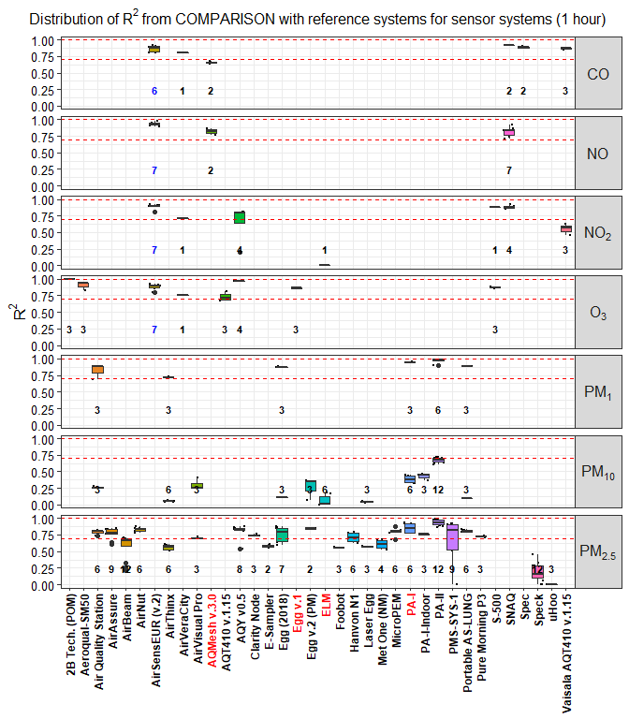

**Figure S3.** Distribution of from the comparison of all sensor systems against reference systems. Records were averaged over a time-scale of 1 hour. Numbers in bold indicate the number of open source (blue) and black box (black) records. Names of ‘living’ and ‘non-living’ sensors are indicated in black and red color, respectively.

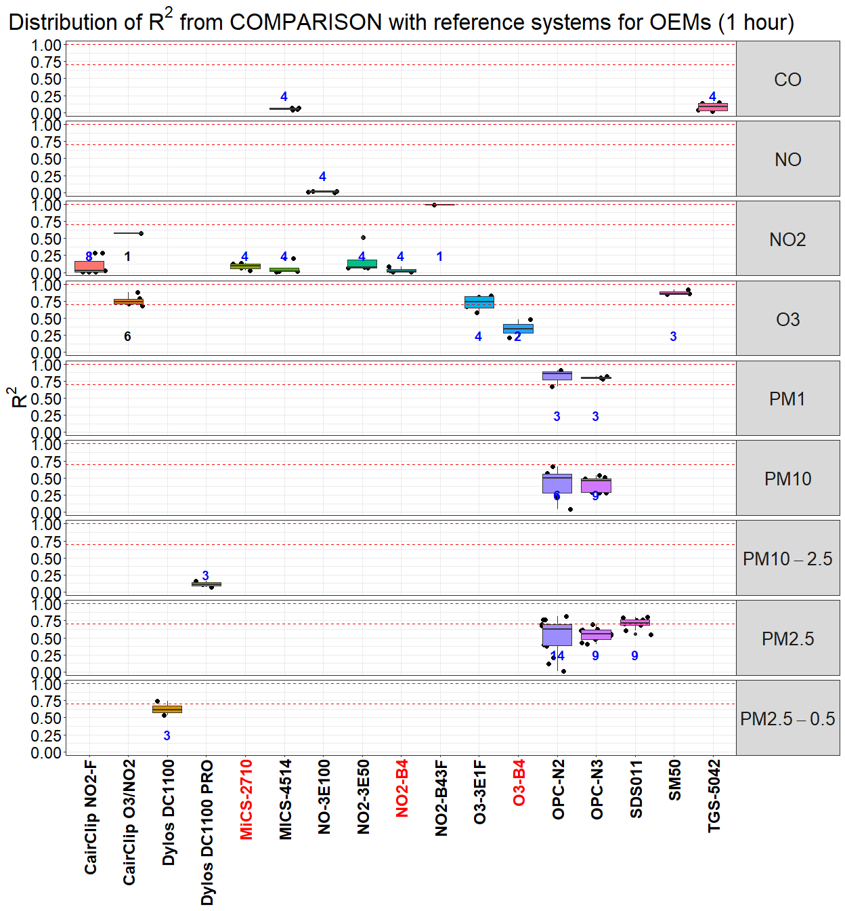

**Figure S4.** Distribution of from the comparison of all OEMs against reference systems. Records were averaged over a time-scale of 1 hour. Numbers in bold indicate the number of open source (blue) and black box (black) records. Names of ‘living’ and ‘non-living’ sensors are indicated in black and red color, respectively.

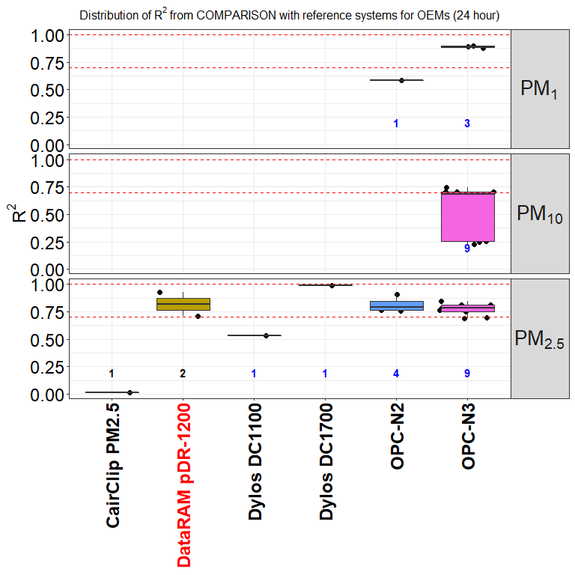

**Figure S5.** Distribution of from the comparison of all OEMs against reference systems. Records were averaged over a time-scale of 24 hour. Numbers in bold indicate the number of open source (blue) and black box (black) records. Names of ‘living’ and ‘non-living’ sensors are indicated in black and red color, respectively.

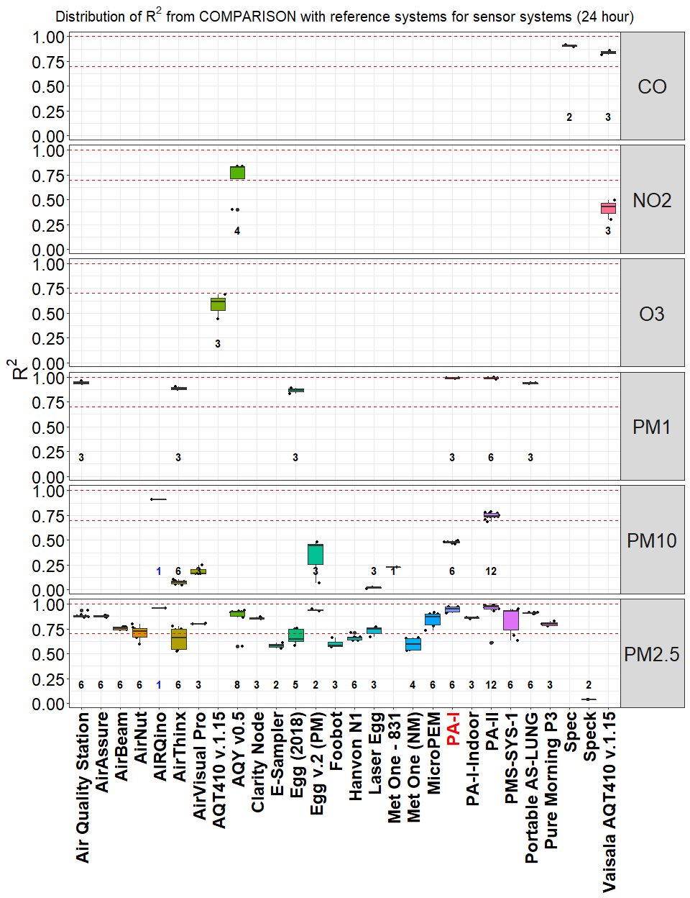

**Figure S6.** Distribution of from the comparison of all sensor systems against reference systems. Records were averaged over a time-scale of 24 hour. Numbers in bold indicate the number of open source (blue) and black box (black) records. Names of ‘living’ and ‘non-living’ sensors are indicated in black and red color, respectively.

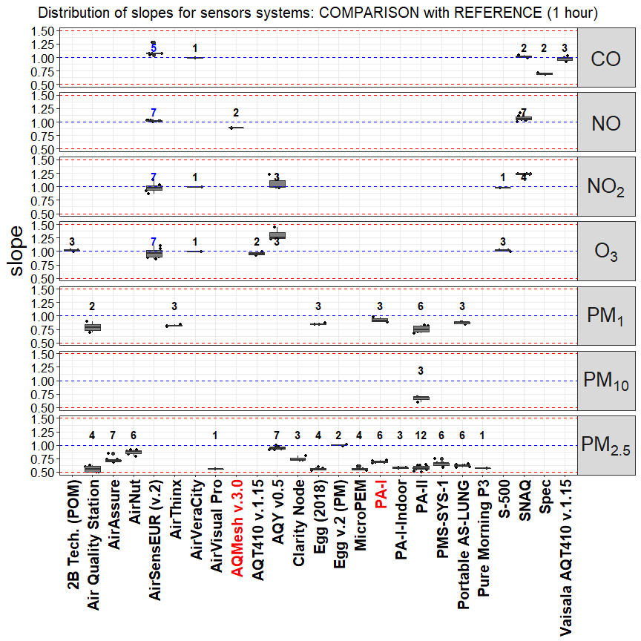

**Figure S7.** Distribution of slopes from the comparison of sensors systems against the reference. Only records with > 0.7 and 0.5 < slope < 1.5 are shown. Records were averaged over a time-scale of 1 hour. Numbers in bold indicate the number of open source (blue) and black box (black) records. Names of ‘living’ and ‘non-living’ sensors are indicated in black and red color, respectively.

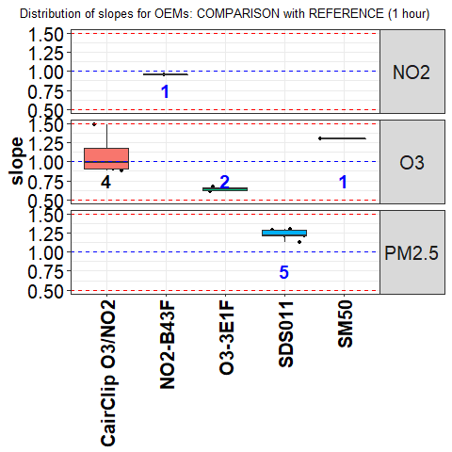

**Figure S8.** Distribution of slopes from the comparison of OEMs against the reference. Only records with > 0.7 and 0.5 < slope < 1.5 are shown. Records were averaged over a time-scale of 1 hour. Numbers in bold indicate the number of open source (blue) and black box (black) records. Names of ‘living’ and ‘non-living’ sensors are indicated in black and red color, respectively.

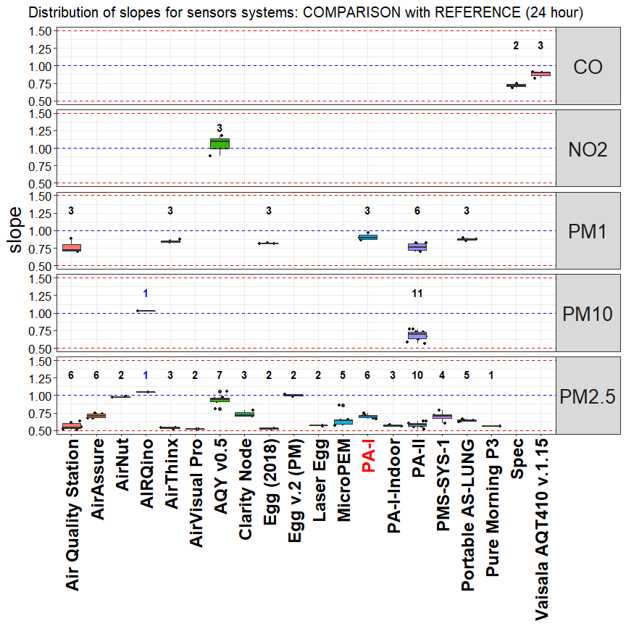

**Figure S9.** Distribution of slopes from the comparison of sensors systems against the reference. Only records with > 0.7 and 0.5 < slope < 1.5 are shown. Records were averaged over a time-scale of 24 hour. Numbers in bold indicate the number of open source (blue) and black box (black) records. Names of ‘living’ and ‘non-living’ sensors are indicated in black and red color, respectively.

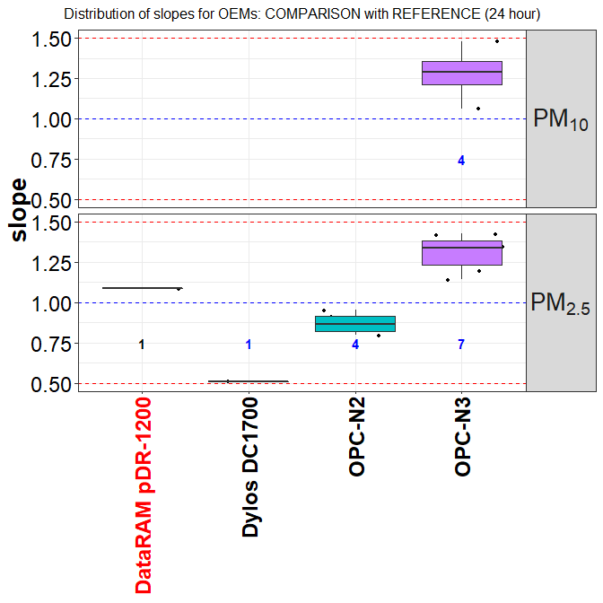

**Figure S10.** Distribution of slopes from the comparison of OEMs against the reference. Only records with > 0.7 and 0.5 < slope < 1.5 are shown. Records were averaged over a time-scale of 24 hour. Numbers in bold indicate the number of open source (blue) and black box (black) records. Names of ‘living’ and ‘non-living’ sensors are indicated in black and red color, respectively.

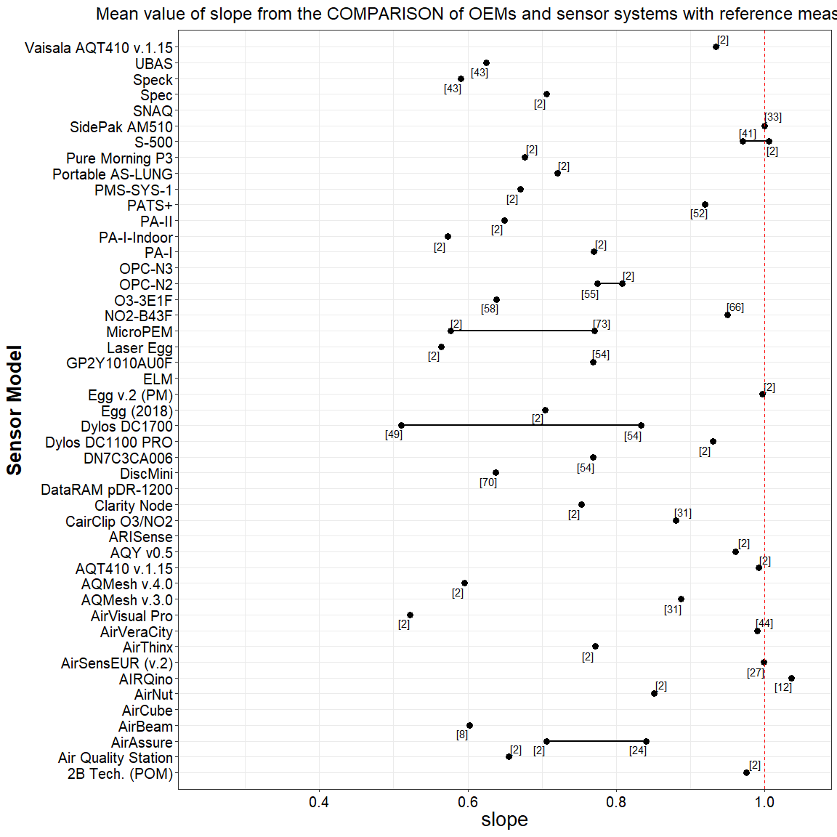

**Figure S11.** Mean for obtained from the comparison of OEMs and sensor systems against reference measurements.

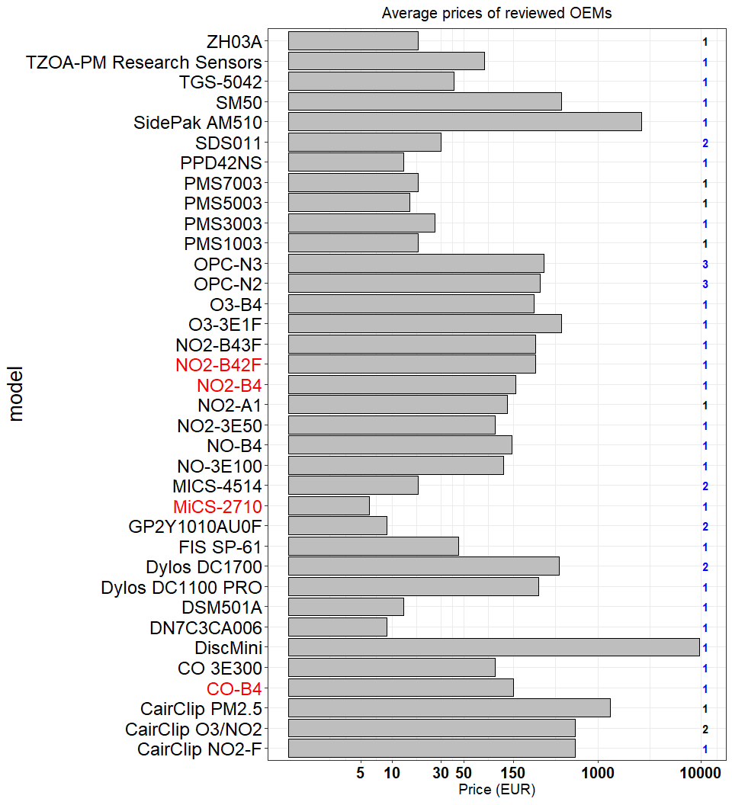

**Figure S12.** Prices of OEMs available on the market (Numbers in bold indicates the number of pollutant measured by each sensor. x-axis uses logarithmic scale). Numbers in bold indicate the number of open source (blue) and black box (black) records. Names of ‘living’ and ‘non-living’ sensors are indicated in black and red color, respectively.

Table S7. Shortlist of sensor systems showing good agreement with reference systems ( > 0.85; 0.8 < slope < 1.2) for 24 hour time averaged data.

|  |  |  |  |  |  |  |  |
| --- | --- | --- | --- | --- | --- | --- | --- |
| model | pollutant | mean | mean slope | open/close | living | commercial | price (EUR) |
| **PA-I** |  | 0.9867 | 0.9086 | black box | N | commercial | 132 |
| **PA-II** |  | 0.9937 | 0.8252 | black box | Y | commercial | 176 |
| **Egg (2018)** |  | 0.8776 | 0.8145 | black box | Y | commercial | 219 |
| **Egg v.2 (PM)** |  | 0.9375 | 1.001 | black box | Y | commercial | 246 |
| **AirThinx** |  | 0.8858 | 0.8483 | black box | Y | commercial | 880 |
| **Portable AS-LUNG** |  | 0.9347 | 0.876 | black box | Y | non commercial | 880 |
| **AIRQino** | , | 0.909 | 0.972 | open source | Y | non commercial | 1000 |
| **Air Quality Station** |  | 0.94 | 0.89 | black box | Y | non commercial | 1760 |
| **AQY v0.5** |  | 0.9092 | 0.9393 | black box | updated | commercial | 2640 |
| **Vaisala AQT410 v.1.15** |  | 0.8612 | 0.9105 | black box | Y | commercial | 3256 |

Bibliography

1. Alvarado, M. *et al.* Towards the Development of a Low Cost Airborne Sensing System to Monitor Dust Particles after Blasting at Open-Pit Mine Sites. *Sensors* **15**, 19667–19687 (2015).

2. AQ-SPEC, District, S. C. A. Q. M. & District, S. C. A. Q. M. *Air Quality Sensor Performance Evaluation Reports.* (2015).

3. Austin, E., Novosselov, I., Seto, E. & Yost, M. G. Laboratory Evaluation of the Shinyei PPD42NS Low-Cost Particulate Matter Sensor. *PLOS ONE* **10**, e0137789 (2015).

4. Badura, M., Batog, P., Drzeniecka-Osiadacz, A. & Modzel, P. Optical particulate matter sensors in PM $ measurements in atmospheric air. *E3S Web of Conferences* **44**, 00006 (2018).

5. Barrett, J. P. The Coefficient of Determination—Some Limitations. *The American Statistician* **28**, 19–20 (1974).

6. Bettair. *Bettair - Solving Cities Air Pollution bettair cities*.

7. Bigi, A., Mueller, M., Grange, S. K., Ghermandi, G. & Hueglin, C. Performance of NO, NO low cost sensors and three calibration approaches within a real world application. *Atmospheric Measurement Techniques* **11**, 3717–3735 (2018).

8. Borghi, F. *et al.* Precision and Accuracy of a Direct-Reading Miniaturized Monitor in PM2.5 Exposure Assessment. *Sensors* **18**, 3089 (2018).

9. Borrego, C. *et al.* Assessment of air quality microsensors versus reference methods: The EuNetAir joint exercise. *Atmospheric Environment* **147**, 246–263 (2016).

10. Budde, M. *et al.* Suitability of the Low-Cost SDS011 Particle Sensor for Urban PM-Monitoring. (2018).

11. Castell, N. *et al.* Can commercial low-cost sensor platforms contribute to air quality monitoring and exposure estimates? *Environment International* **99**, 293–302 (2017).

12. Cavaliere, A. *et al.* Development of Low-Cost Air Quality Stations for Next Generation Monitoring Networks: Calibration and Validation of PM2.5 and PM10 Sensors. *Sensors* **18**, 2843 (2018).

13. CEN. Ambient air - Standard method for the measurement of the concentration of carbon monoxide by non-dispersive infrared spectroscopy, (EN 14626:2012). European Committee for Standardization. (2012).

14. CEN. Ambient air - Standard method for the measurement of the concentration of nitrogen dioxide and nitrogen monoxide by chemiluminescence (EN 14211:2012). European Committee for Standardization. (2012).

15. CEN. Ambient air - Standard method for the measurement of the concentration of ozone by ultraviolet photometry, (EN 14625:2012). European Committee for Standardization. (2012).

16. CEN. Ambient air - Standard method for the measurement of the concentration of sulphur dioxide by ultraviolet fluorescence, (EN 14212:2012). European Committee for Standardization. (2012).

17. CEN. Ambient air - Standard gravimetric measurement method for the determination of the PM10 or PM2,5 mass concentration of suspended particulate matter (EN 12341:2014). European Committee for Standardization. (2014).

18. Chakrabarti, B., Fine, P. M., Delfino, R. & Sioutas, C. Performance evaluation of the active-flow personal DataRAM PM2.5 mass monitor (Thermo Anderson pDR-1200) designed for continuous personal exposure measurements. *Atmospheric Environment* **38**, 3329–3340 (2004).

19. Cordero, J. M., Borge, R. & Narros, A. Using statistical methods to carry out in field calibrations of low cost air quality sensors. *Sensors and Actuators B: Chemical* **267**, 245–254 (2018).

20. Crilley, L. R. *et al.* Evaluation of a low-cost optical particle counter (Alphasense OPC-N2) for ambient air monitoring. *Atmospheric Measurement Techniques* **11**, 709–720 (2018).

21. Cross, E. S. *et al.* Use of electrochemical sensors for measurement of air pollution: Correcting interference response and validating measurements. *Atmos. Meas. Tech.* 14 (2017).

22. Dacunto, P. J. *et al.* Determining PM $ calibration curves for a low-cost particle monitor: Common indoor residential aerosols. *Environmental Science: Processes & Impacts* **17**, 1959–1966 (2015).

23. Duvall, R. M. *et al.* Performance Evaluation and Community Application of Low-Cost Sensors for Ozone and Nitrogen Dioxide. *Sensors* **16**, 1698 (2016).

24. Feinberg, S. *et al.* Long-term evaluation of air sensor technology under ambient conditions in Denver, Colorado. *Atmospheric Measurement Techniques* **11**, 4605–4615 (2018).

25. Gao, M., Cao, J. & Seto, E. A distributed network of low-cost continuous reading sensors to measure spatiotemporal variations of PM2.5 in Xi’an, China. *Environmental Pollution* **199**, 56–65 (2015).

26. Gerboles, M., Spinelle, L. & Signorini, M. *AirSensEUR: An open data/software/hardware multi-sensor platform for air quality monitoring. Part A: Sensor shield*. (Publications Office of the European Union, 2015). doi:[10.2788/30927](https://doi.org/10.2788/30927)

27. Gerboles, M. *Calibration of 5 AirSensEUR boxes in the Netherlands; proof of Concept AirSensEUR*. (European Commission - Joint Research Centre, 2019).

28. Gillooly, S. E. *et al.* Development of an in-home, real-time air pollutant sensor platform and implications for community use. *Environmental Pollution* **244**, 440–450 (2019).

29. Han, I., Symanski, E. & Stock, T. H. Feasibility of using low-cost portable particle monitors for measurement of fine and coarse particulate matter in urban ambient air. *Journal of the Air & Waste Management Association* **67**, 330–340 (2017).

30. Holstius, D. M., Pillarisetti, A., Smith, K. R. & Seto, E. Field calibrations of a low-cost aerosol sensor at a regulatory monitoring site in California. *Atmospheric Measurement Techniques* **7**, 1121–1131 (2014).

31. Jiao, W. *et al.* Community Air Sensor Network (CAIRSENSE) project: Evaluation of low-cost sensor performance in a suburban environment in the southeastern United States. *Atmospheric Measurement Techniques* **9**, 5281–5292 (2016).

32. Jovašević-Stojanović, M. *et al.* On the use of small and cheaper sensors and devices for indicative citizen-based monitoring of respirable particulate matter. *Environmental Pollution* **206**, 696–704 (2015).

33. Karagulian, F., Belis, C. A., Lagler, F., Barbiere, M. & Gerboles, M. Evaluation of a portable nephelometer against the Tapered Element Oscillating Microbalance method for monitoring PM2.5. *Journal of Environmental Monitoring* **14**, 2145–2153 (2012).

34. Kelly, K. E. *et al.* Ambient and laboratory evaluation of a low-cost particulate matter sensor. *Environmental Pollution* **221**, 491–500 (2017).

35. KEY-VOCs. *Metrology for VOC indicators in air pollution and climate change. Revision of the testing protocol and procedure for calibration based on laboratory validation, final report. ENV56 KEY-VOCs.* (2017).

36. Kumar, P. *et al.* The rise of low-cost sensing for managing air pollution in cities. *Environment International* **75**, 199–205 (2015).

37. Kunak. *Wireless Particle counter for Outdoors Kunak AIR P10*. *Kunak*

38. Laquai, B. Particle Distribution Dependent Inaccuracy of the Plantower PMS5003 low-cost PM-sensor. (2017).

39. Lewis, A. C., Schneidemesser, E. von & Peltier, R. *Low-cost sensors for the measurement of atmospheric composition: Overview of topic and future applications (World Meteorological Organization) WMO-No. 1215.* (2018).

40. Lewis, A. & Edwards, P. Validate personal air-pollution sensors. *Nature News* **535**, 29 (2016).

41. Lin, C. *et al.* Evaluation and calibration of Aeroqual series 500 portable gas sensors for accurate measurement of ambient ozone and nitrogen dioxide. *Atmospheric Environment* **100**, 111–116 (2015).

42. Liu, H.-Y., Schneider, P., Haugen, R. & Vogt, M. Performance Assessment of a Low-Cost PM2.5 Sensor for a near Four-Month Period in Oslo, Norway. *Atmosphere* **10**, 41 (2019).

43. Manikonda, A., Zíková, N., Hopke, P. K. & Ferro, A. R. Laboratory assessment of low-cost PM monitors. *Journal of Aerosol Science* **102**, 29–40 (2016).

44. Marjovi, A., Arfire, A. & Martinoli, A. Extending Urban Air Quality Maps Beyond the Coverage of a Mobile Sensor Network: Data Sources, Methods, and Performance Evaluation. in *Proceedings of the 2017 International Conference on Embedded Wireless Systems and Networks* 12–23 (Junction Publishing, 2017).

45. Mead, M. I. *et al.* The use of electrochemical sensors for monitoring urban air quality in low-cost, high-density networks. *Atmospheric Environment* **70**, 186–203 (2013).

46. Mijling, B., Jiang, Q., Jonge, D. de & Bocconi, S. Practical field calibration of electrochemical NO2 sensors for urban air quality applications. *Atmos. Meas. Tech. Discuss.* **2017**, 1–25 (2017).

47. Mueller, M., Meyer, J. & Hueglin, C. Design of an ozone and nitrogen dioxide sensor unit and its long-term operation within a sensor network in the city of Zurich. *Atmos. Meas. Tech.* 17 (2017).

48. Mukherjee, A., Stanton, L. G., Graham, A. R. & Roberts, P. T. Assessing the Utility of Low-Cost Particulate Matter Sensors over a 12-Week Period in the Cuyama Valley of California. *Sensors* **17**, 1805 (2017).

49. Northcross, A. L. *et al.* A low-cost particle counter as a realtime fine-particle mass monitor. *Environmental Science: Processes & Impacts* **15**, 433–439 (2013).

50. Olivares, G. & Edwards, S. The Outdoor Dust Information Node (ODIN) – development and performance assessment of a low cost ambient dust sensor. *Atmospheric Measurement Techniques Discussions* **8**, 7511–7533 (2015).

51. Piedrahita, R. *et al.* The next generation of low-cost personal air quality sensors for quantitative exposure monitoring. *Atmospheric Measurement Techniques* **7**, 3325–3336 (2014).

52. Pillarisetti, A. *et al.* Small, Smart, Fast, and Cheap: Microchip-Based Sensors to Estimate Air Pollution Exposures in Rural Households. *Sensors (Basel, Switzerland)* **17**, (2017).

53. Popoola, O. A. M., Stewart, G. B., Mead, M. I. & Jones, R. L. Development of a baseline-temperature correction methodology for electrochemical sensors and its implications for long-term stability. *Atmospheric Environment* **147**, 330–343 (2016).

54. Sousan, S., Koehler, K., Hallett, L. & Peters, T. M. Evaluation of the Alphasense optical particle counter (OPC-N2) and the Grimm portable aerosol spectrometer (PAS-1.108). *Aerosol Science and Technology* **50**, 1352–1365 (2016).

55. Sousan, S. *et al.* Inter-comparison of low-cost sensors for measuring the mass concentration of occupational aerosols. *Aerosol Science and Technology* **50**, 462–473 (2016).

56. Spinelle, L., Gerboles, M., Aleixandre, M. & Bonavitacola, F. Evaluation of metal oxides sensors for the monitoring of o3 in ambient air at ppb level. *Chemical Engineering Transactions* 319–324 (2016). doi:[10.3303/CET1654054](https://doi.org/10.3303/CET1654054)

57. Spinelle, L., Gerboles, M., Kotsev, A. & Signorini, M. *Evaluation of low-cost sensors for air pollution monitoring: Effect of gaseous interfering compounds and meteorological conditions*. (Publications Office of the European Union, 2017). doi:[10.2760/548327](https://doi.org/10.2760/548327)

58. Spinelle, L., Gerboles, M., Villani, M. G., Aleixandre, M. & Bonavitacola, F. Field calibration of a cluster of low-cost available sensors for air quality monitoring. Part A: Ozone and nitrogen dioxide. *Sensors and Actuators B: Chemical* **215**, 249–257 (2015).

59. Spinelle, L., Gerboles, M., Villani, M. G., Aleixandre, M. & Bonavitacola. Field calibration of a cluster of low-cost available sensors for air quality monitoring. Part. B: NO, CO and CO2. *Sensors and Actuators B: Chemical* **in preparation**,

60. Spinelle, L., Gerboles, M. & Aleixandre, M. Performance Evaluation of Amperometric Sensors for the Monitoring of O 3 and NO 2 in Ambient Air at ppb Level. *Procedia Engineering* **120**, 480–483 (2015).

61. Spinelle, L., Gerboles, M. & Aleixandre, M. *Report of laboratory and in-situ validation of micro-sensor for monitoring ambient air pollution - O12: CairClipO3/NO2 of CAIRPOL (F)*. (Publications Office of the European Union, 2013).

62. Spinelle, L., Gerboles, M. & Aleixandre, M. *Report of laboratory and in-situ validation of micro-sensor for monitoring ambient air pollution - NO9: CairClipNO2 of CAIRPOL (F)*. (Publications Office of the European Union, 2013).

63. Steinle, S. *et al.* Personal exposure monitoring of PM 2.5 in indoor and outdoor microenvironments. *Science of The Total Environment* **508**, 383–394 (2015).

64. Sun, L. *et al.* Development and Application of a Next Generation Air Sensor Network for the Hong Kong Marathon 2015 Air Quality Monitoring. *Sensors (Basel, Switzerland)* **16**, (2016).

65. Sun, L., Westerdahl, D. & Ning, Z. Development and Evaluation of A Novel and Cost-Effective Approach for Low-Cost NO2 Sensor Drift Correction. *Sensors* **17**, 1916 (2017).

66. Index, T. W. A. Q. *Sensing the Air Quality: Research on Air Quality Sensors. http://aqicn.org/sensor/.* (2019).

67. Agency, U. S. E. P. Evaluation of Elm and Speck Sensors. **EPA/600/R-15/314 November 2015 www.epa.gov/ord**, (2015).

68. Vaughn, D. L., Dye, T. S., Roberts, L., Ray, A. E. & DeWinter, J. L. *Characterization of Low-Cost NO2 Sensors*. 10 (U.S. Environmental Protection Agency Research Triangle Park, North Carolina, 2010).

69. Viana, M. *et al.* Field comparison of portable and stationary instruments for outdoor urban air exposure assessments. *Atmospheric Environment* **123, Part A**, 220–228 (2015).

70. Wang, Y. *et al.* Laboratory Evaluation and Calibration of Three Low-Cost Particle Sensors for Particulate Matter Measurement. *Aerosol Science and Technology* **49**, 1063–1077 (2015).

71. Wei, P. *et al.* Impact Analysis of Temperature and Humidity Conditions on Electrochemical Sensor Response in Ambient Air Quality Monitoring. *Sensors* **18**, 59 (2018).

72. Williams, R., Kaufman, A., Hanley, T., Rice, J. & Garvey, S. *Evaluation of Field-deployed Low Cost PM Sensors*. (2014).

73. Williams, R. *et al.* *Sensor Evaluation Report*. (2014).

74. Zheng, T. *et al.* Field evaluation of low-cost particulate matter sensors in high and low concentration environments. *Atmospheric Measurement Techniques Discussions* 1–40 (2018). doi:[10.5194/amt-2018-111](https://doi.org/10.5194/amt-2018-111)

75. Zikova, N. *et al.* Estimating Hourly Concentrations of PM2.5 across a Metropolitan Area Using Low-Cost Particle Monitors. *Sensors (Basel, Switzerland)* **17**, (2017).

76. Zimmerman, N. *et al.* A machine learning calibration model using random forests to improve sensor performance for lower-cost air quality monitoring. *Atmos. Meas. Tech.* **11**, 291–313 (2018).

**GETTING IN TOUCH WITH THE EU**

**In person**

All over the European Union there are hundreds of Europe Direct information centres. You can find the address of the centre nearest you at: <https://europa.eu/european-union/contact_en>

**On the phone or by email**

Europe Direct is a service that answers your questions about the European Union. You can contact this service:

- by freephone: 00 800 6 7 8 9 10 11 (certain operators may charge for these calls),

- at the following standard number: +32 22999696, or

- by electronic mail via: <https://europa.eu/european-union/contact_en>

**FINDING INFORMATION ABOUT THE EU**

**Online**

Information about the European Union in all the official languages of the EU is available on the Europa website at: <https://europa.eu/european-union/index_en>

**EU publications**

You can download or order free and priced EU publications from EU Bookshop at: <https://publications.europa.eu/en/publications>. Multiple copies of free publications may be obtained by contacting Europe Direct or your local information centre (see <https://europa.eu/european-union/contact_en>).

